**COURSERA**

**MACHINE LEARNING**

**Andrew Ng, Stanford University**

Course Materials: <http://cs229.stanford.edu/materials.html>

**WEEK 1**

What is Machine Learning?

A computer program is said to learn from experience E with respect to some class of tasks T and performance measure P, if its performance at tasks in T, as measured by P, improves with experience E.

Supervised Learning

In supervised learning, we are given a data set and already know what our correct output should look like, having the idea that there is a relationship between the input and the output.

Example 1 - Regression

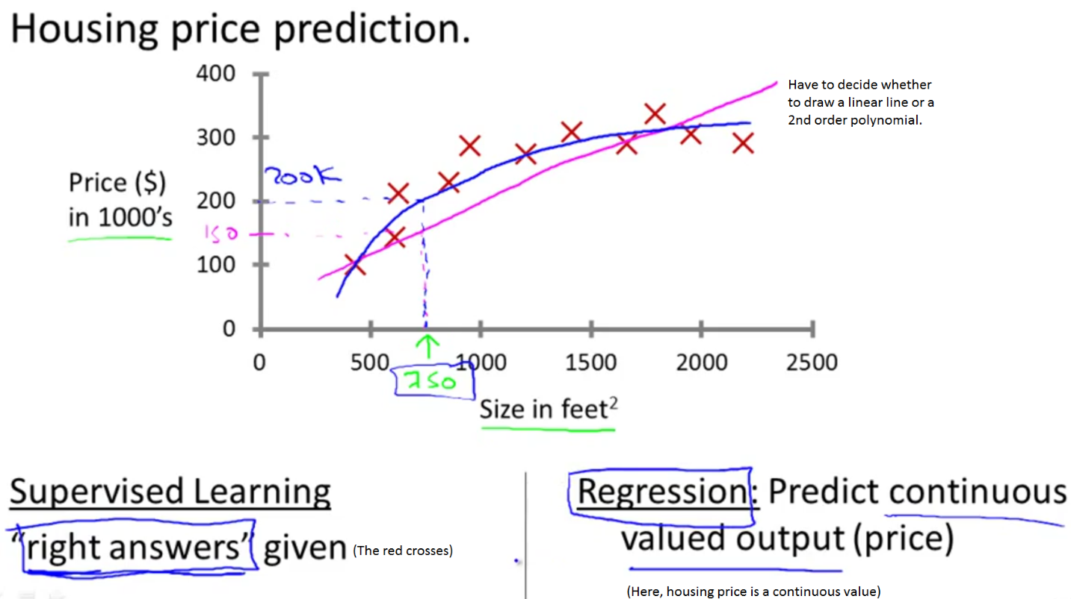

Example 2 - Classification

1. Single Feature:

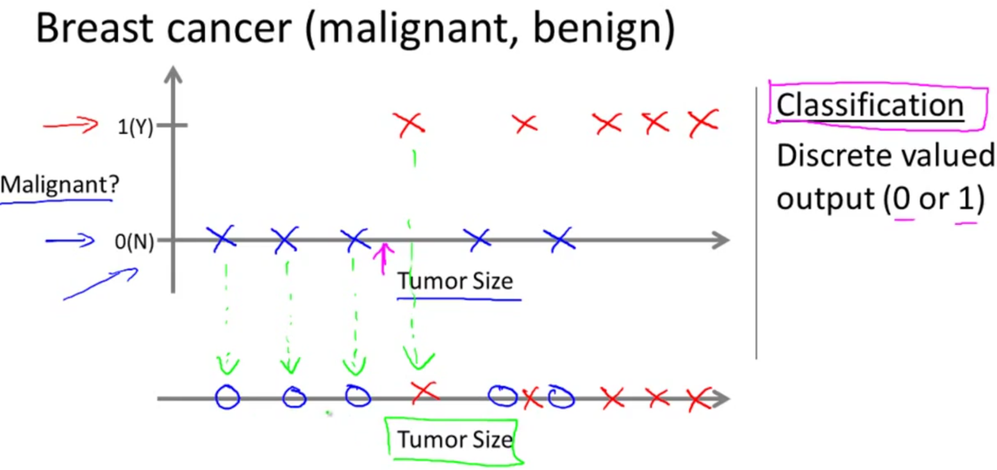

1. Multiple Features:

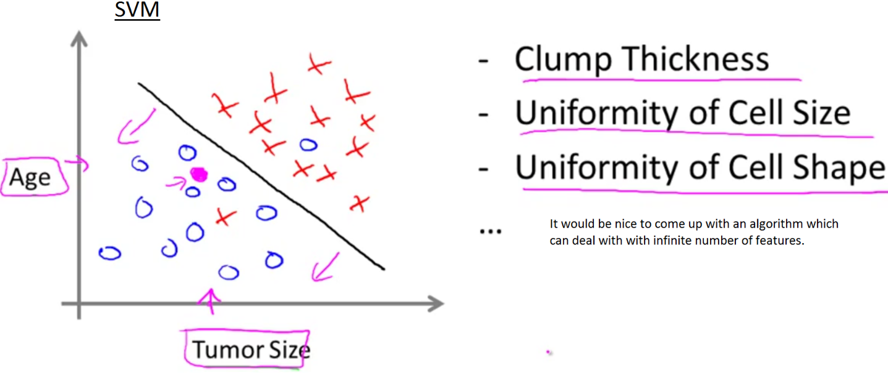

Unsupervised Learning

Unsupervised learning allows us to approach problems with little or no idea what our results should look like. We can derive structure from data where we don't necessarily know the effect of the variables. We can derive this structure by clustering the data based on relationships among the variables in the data. With unsupervised learning there is no feedback based on the prediction results.

Linear Regression

We’ll use *x*(*i*) to denote the “input” variables (features), and *y*(*i*) to denote the “output” or target variable that we are trying to predict. A pair (*x*(*i*),*y*(*i*)) is called a training example, a list of m training examples (*x*(*i*),*y*(*i*)) is called a training set.

Our goal is, given a training set, to learn a function h : X → Y so that h(x) is a “good” predictor for the corresponding value of y.

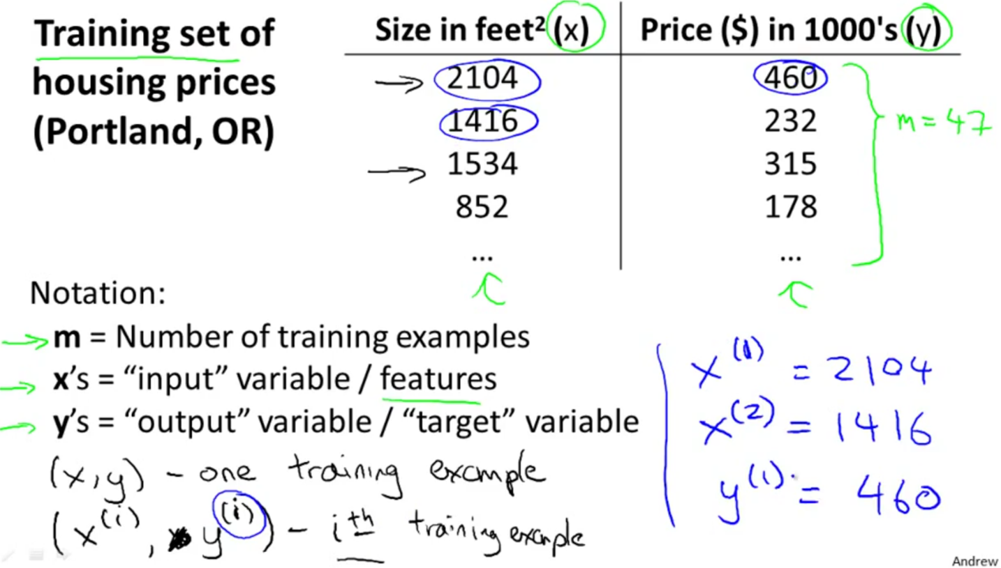

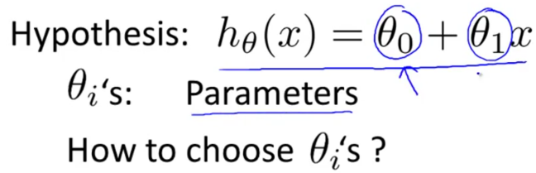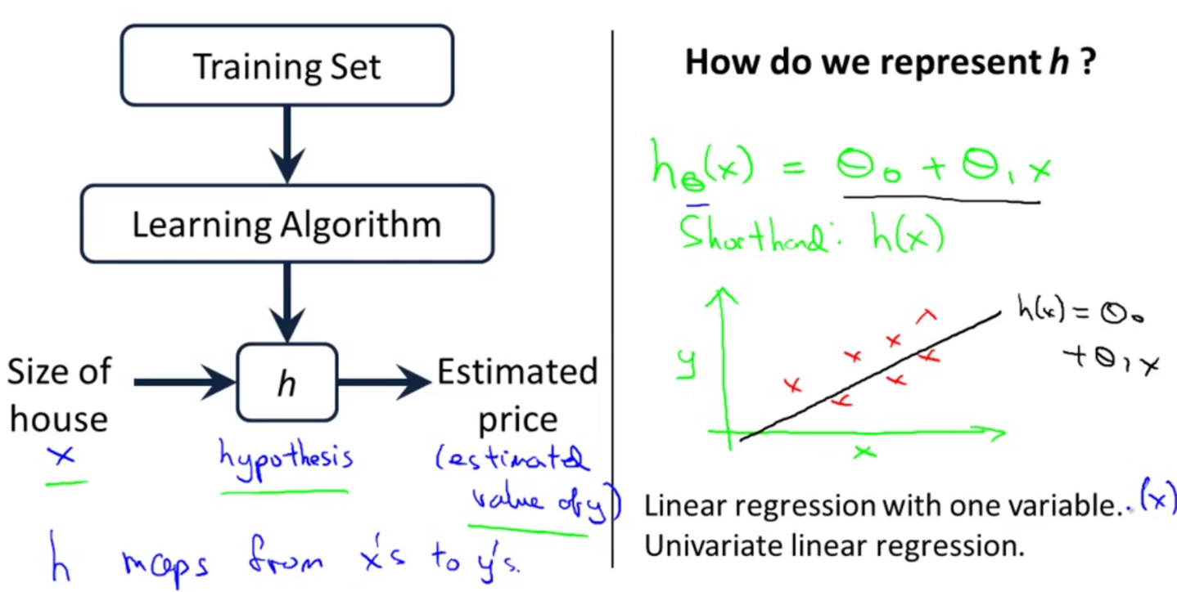

Cost Function

We can measure the accuracy of our hypothesis function by using a **cost function**. This takes an average difference of all the results of the hypothesis with inputs from x's and the actual output y's.

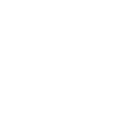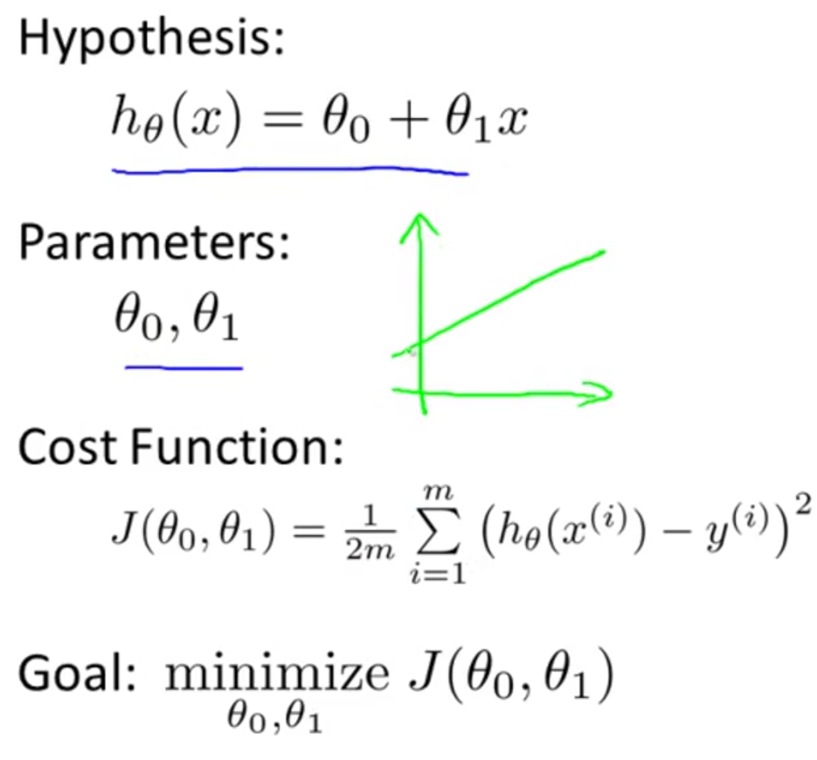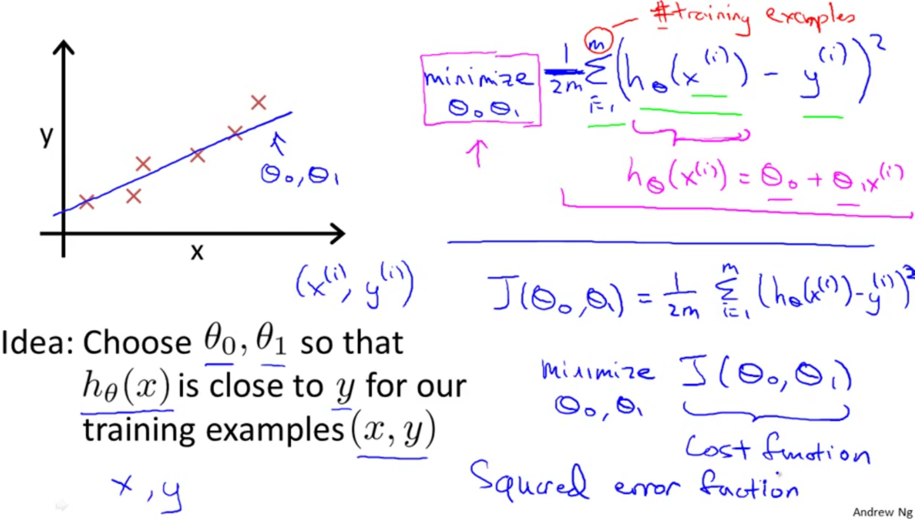

The mean is halved as a convenience for the computation of the gradient descent, as the derivative term of the square function will cancel out the (½) term.

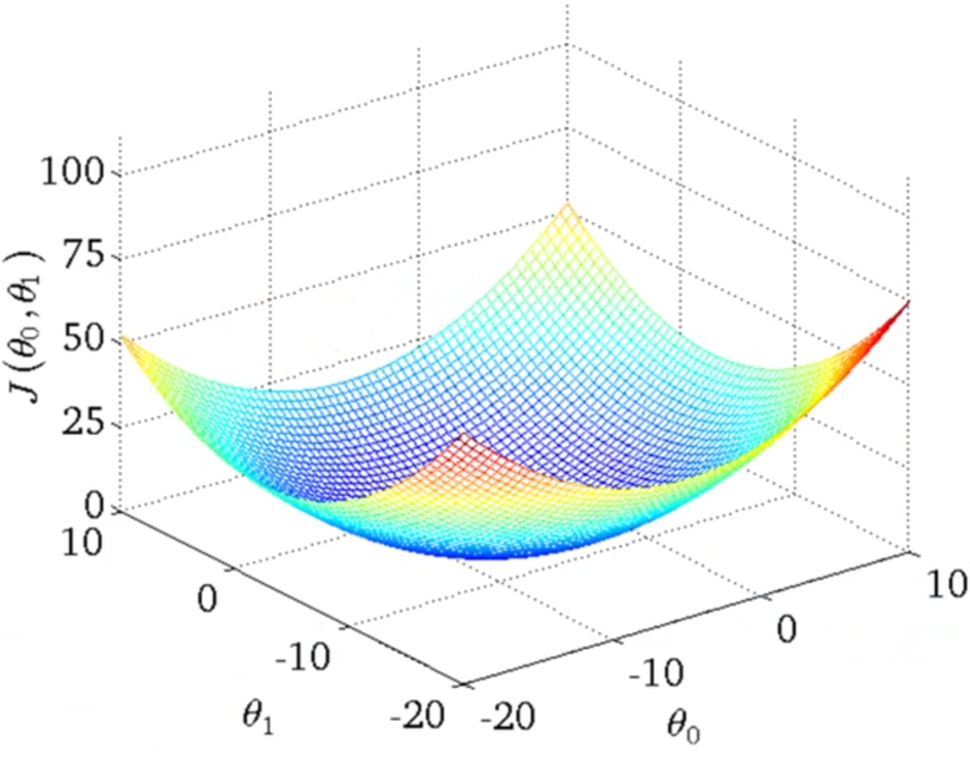

We need an algorithm to automatically find the set of parameters *θ*0 and *θ*1 that minimizes the cost function *J*(*θ*0,*θ*1), which is always a **convex** function.

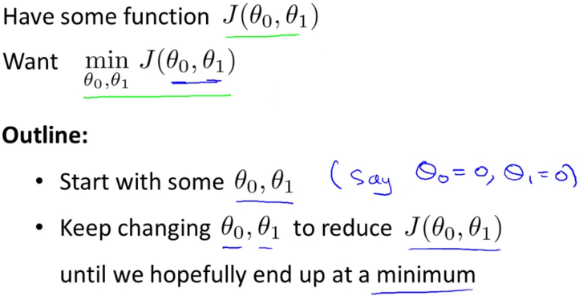Gradient Descent

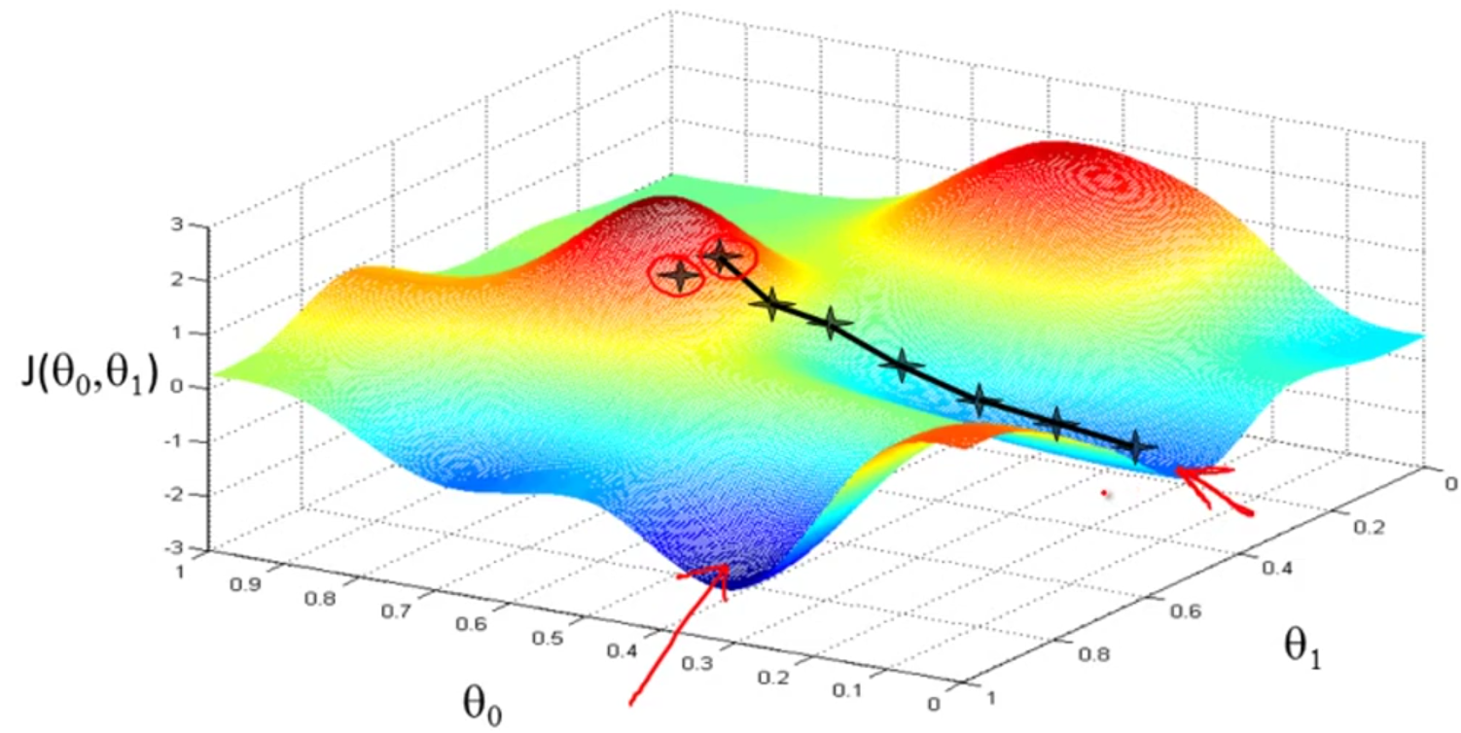Starting point may lead to different local minimum values.

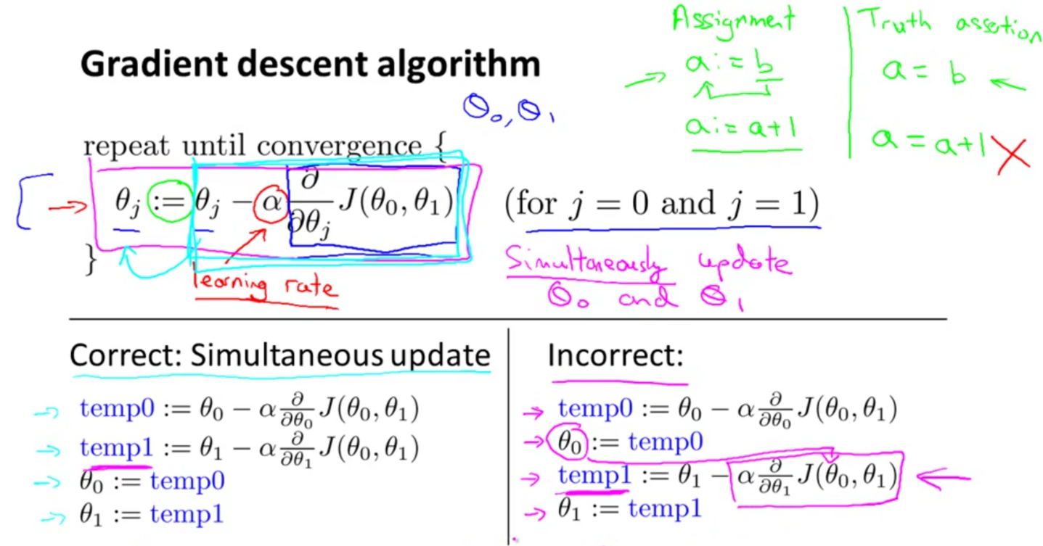

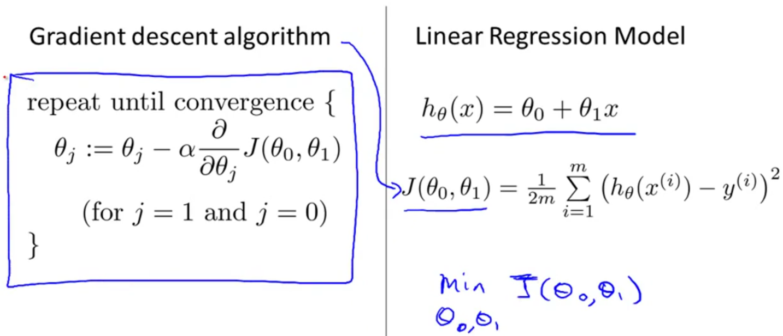

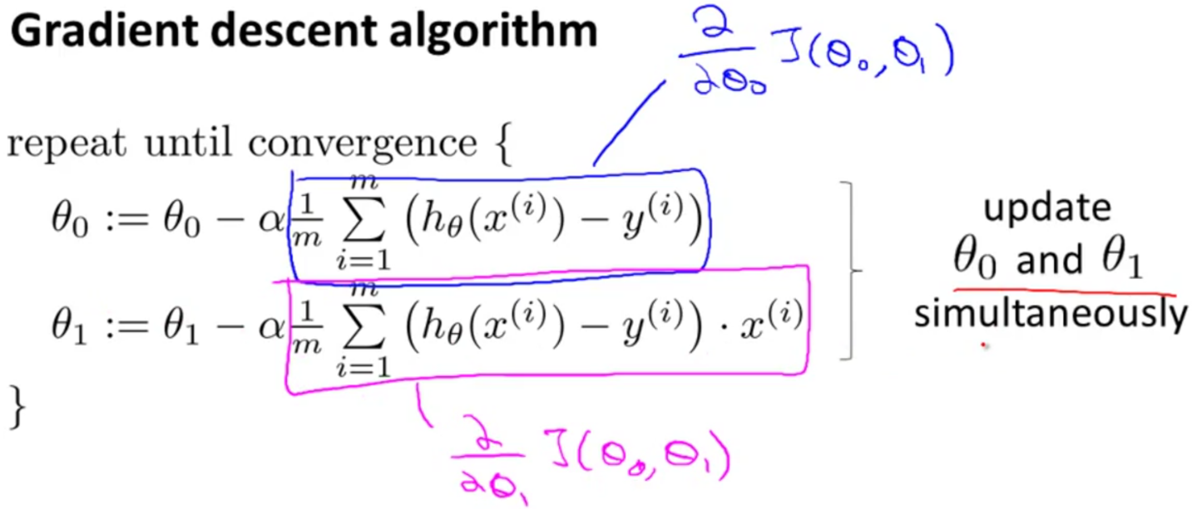

This is simply gradient descent on the original cost function J. This method looks at every example in the entire training set on every step, and is called **batch gradient descent**. Note that, while gradient descent can be susceptible to local minima in general, the optimization problem we have posed here for linear regression has only one global and no other local optima (J is a convex quadratic function); thus gradient descent always converges (assuming the learning rate α is not too large) to the global minimum.

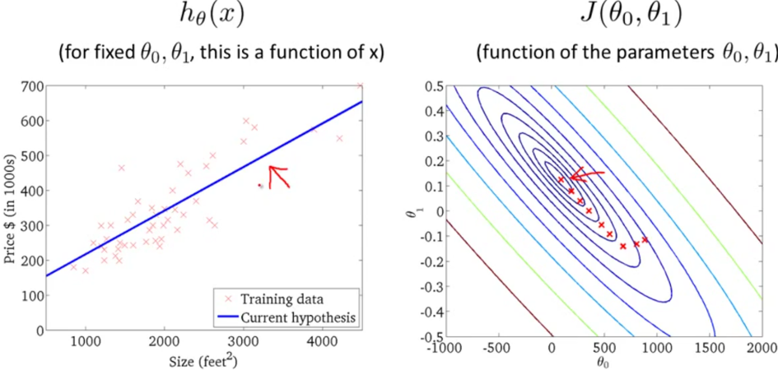

**WEEK 2**

Multivariate Linear Regression

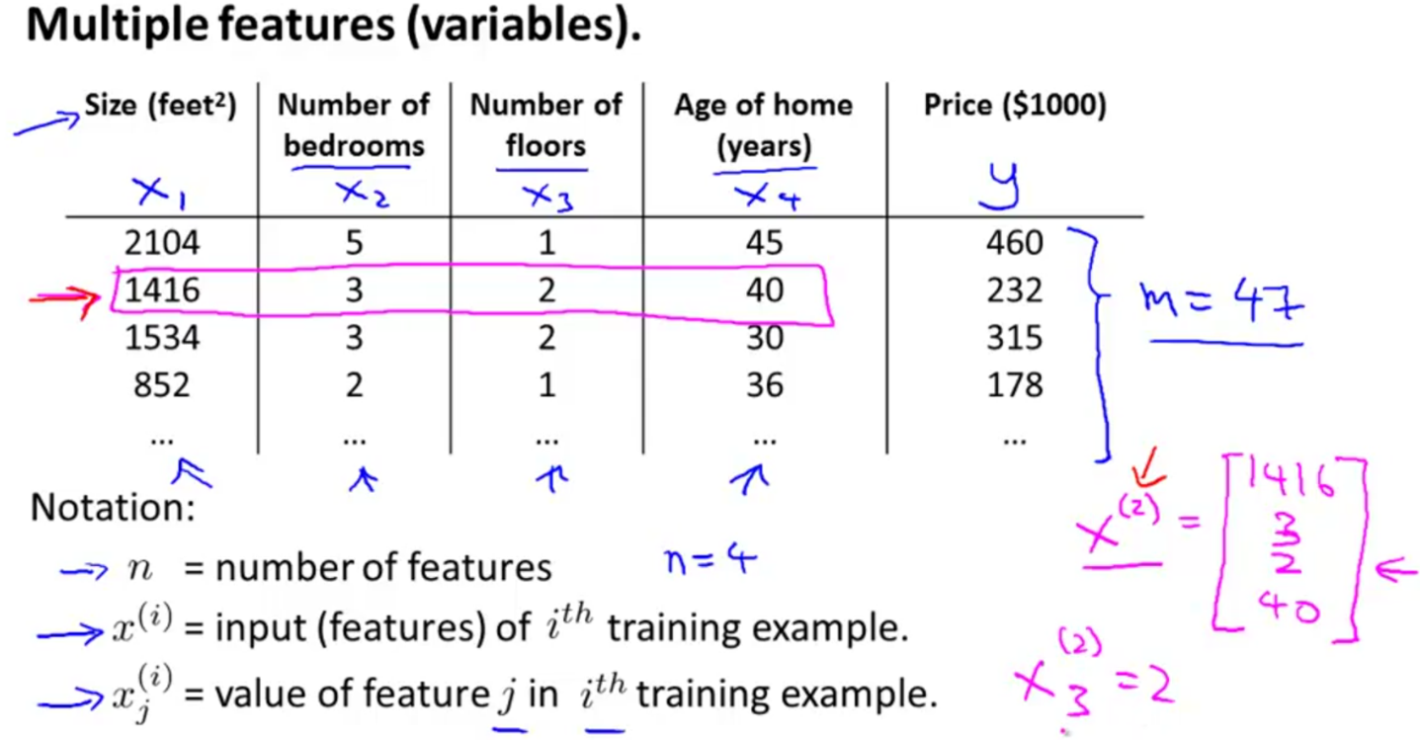

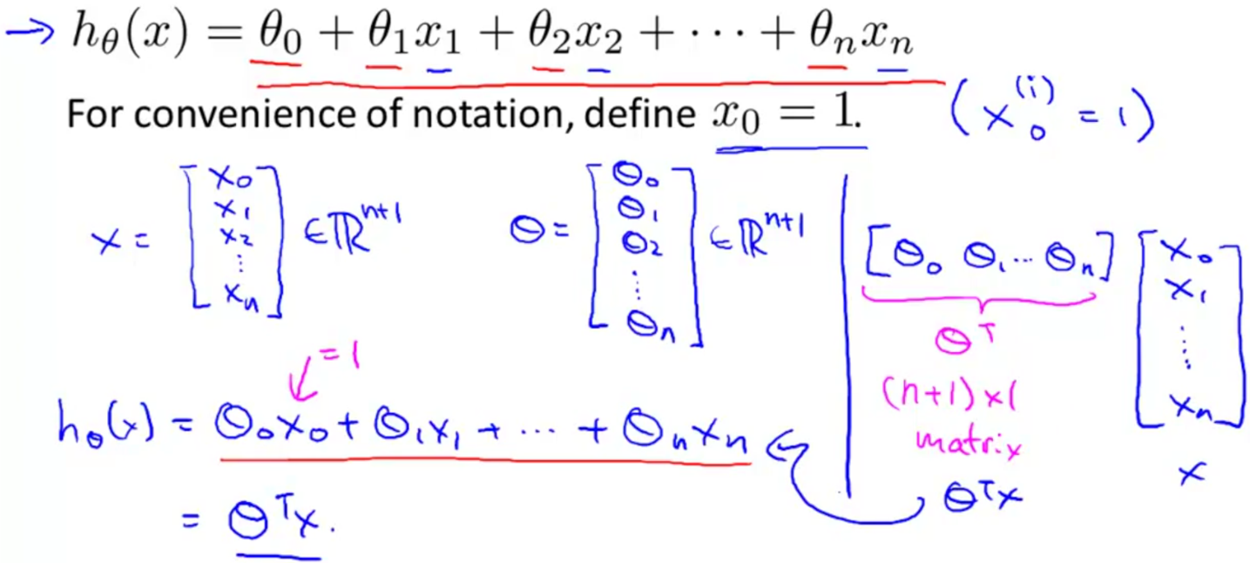

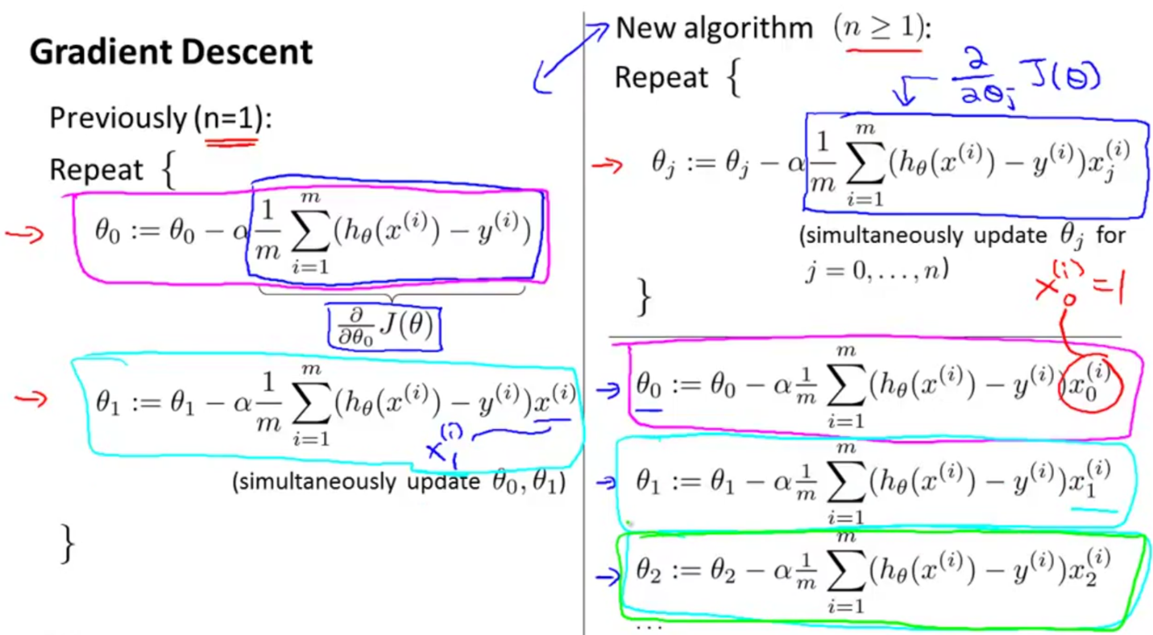

We can speed up gradient descent by having each of our input values in roughly the same range. This is because θ will descend quickly on small ranges and slowly on large ranges, and so will oscillate inefficiently down to the optimum when the variables are very uneven.

Two techniques to help with this are **feature scaling** and **mean normalization**. Feature scaling involves dividing the input values by the range of the input variable, resulting in a new range of just 1. Mean normalization involves subtracting the average value for an input variable from the values for that input variable resulting in a new average value for the input variable of just zero.

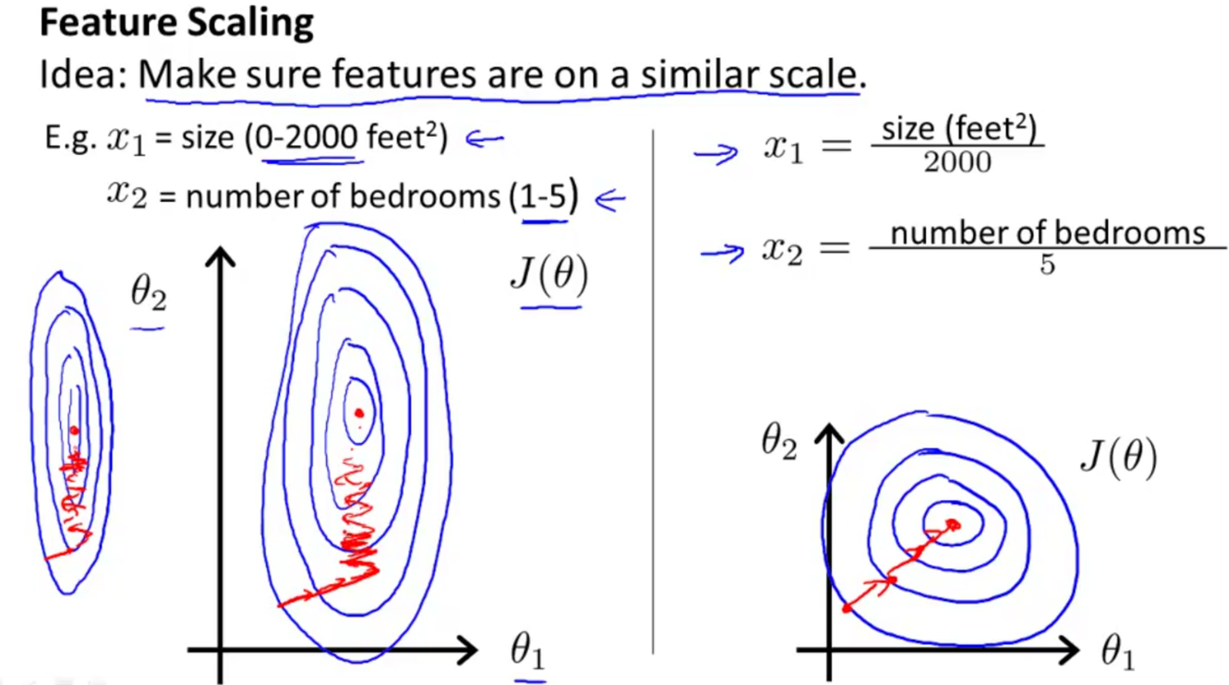

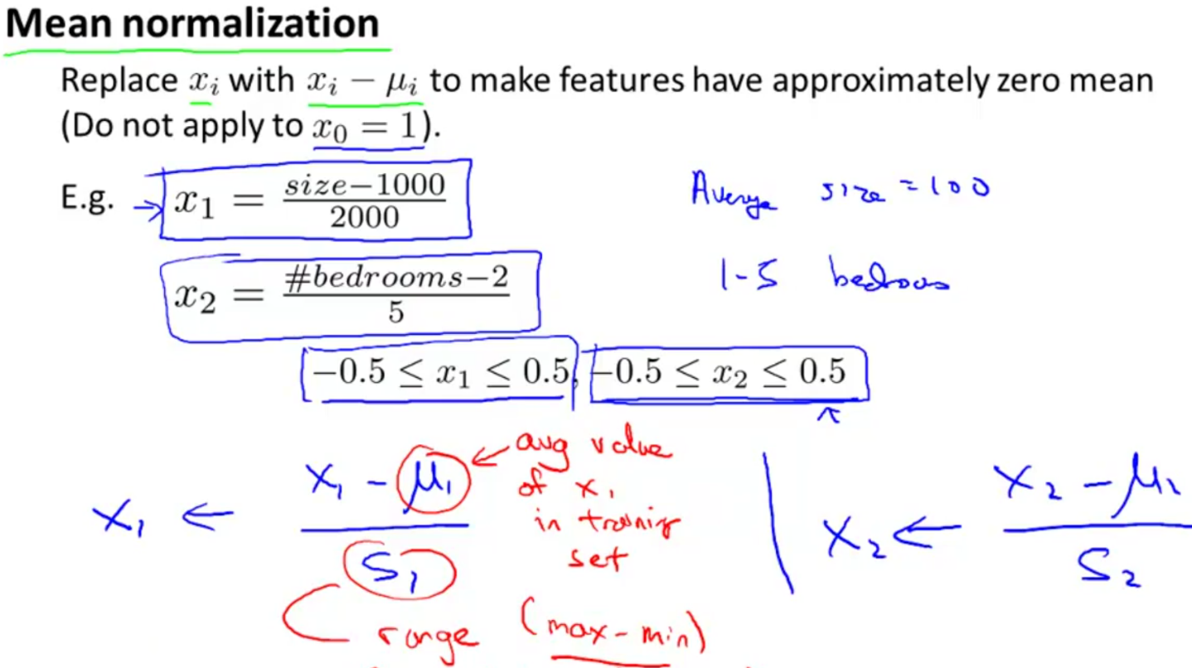

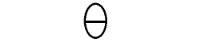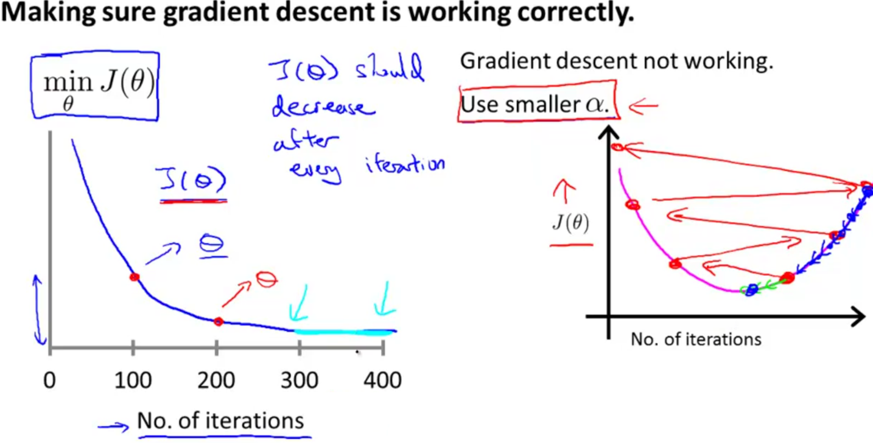

It has been proven that if α is sufficiently small, then J(θ) will decrease on every iteration.

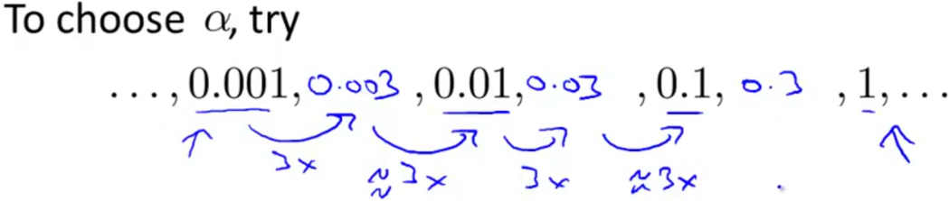

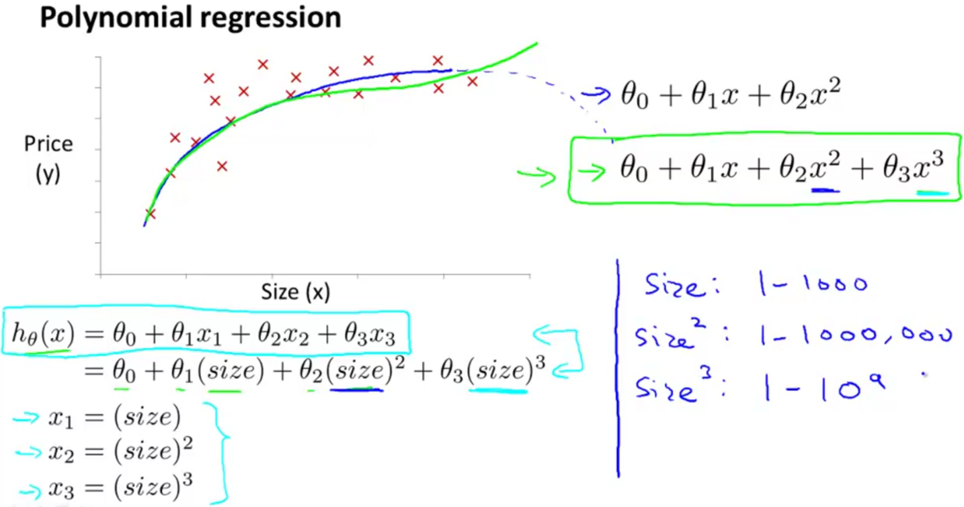

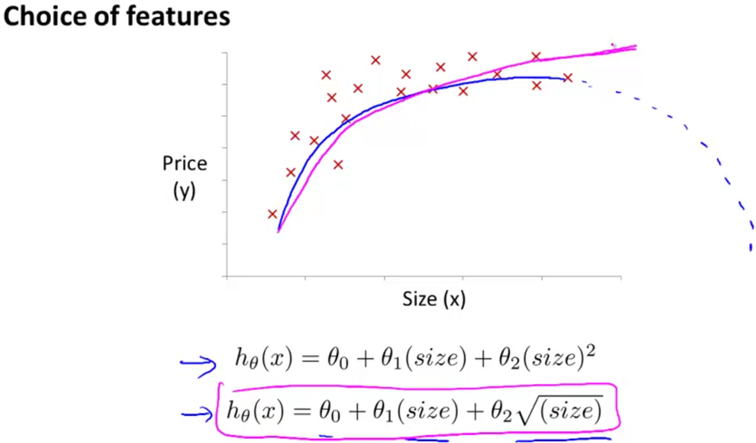

Normal Equation

Gradient descent gives one way of minimizing J. Let’s discuss a second way of doing so, this time performing the minimization explicitly and without resorting to an iterative algorithm. In the "Normal Equation" method, we will minimize J by explicitly taking its derivatives with respect to the θj’s, and setting them to zero. This allows us to find the optimum theta without iteration.

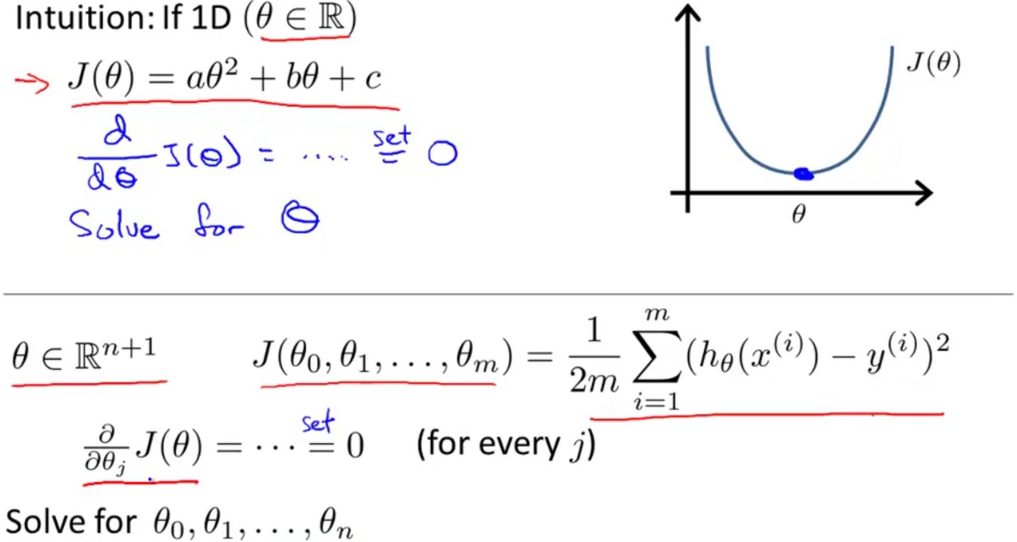

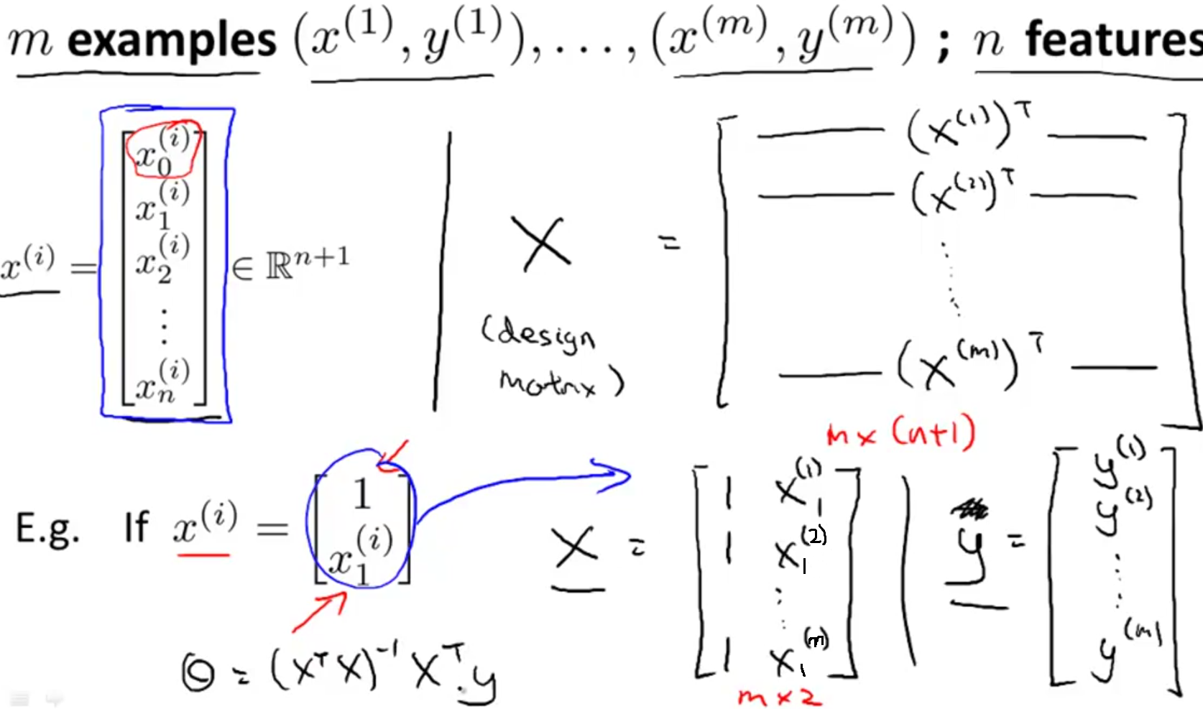

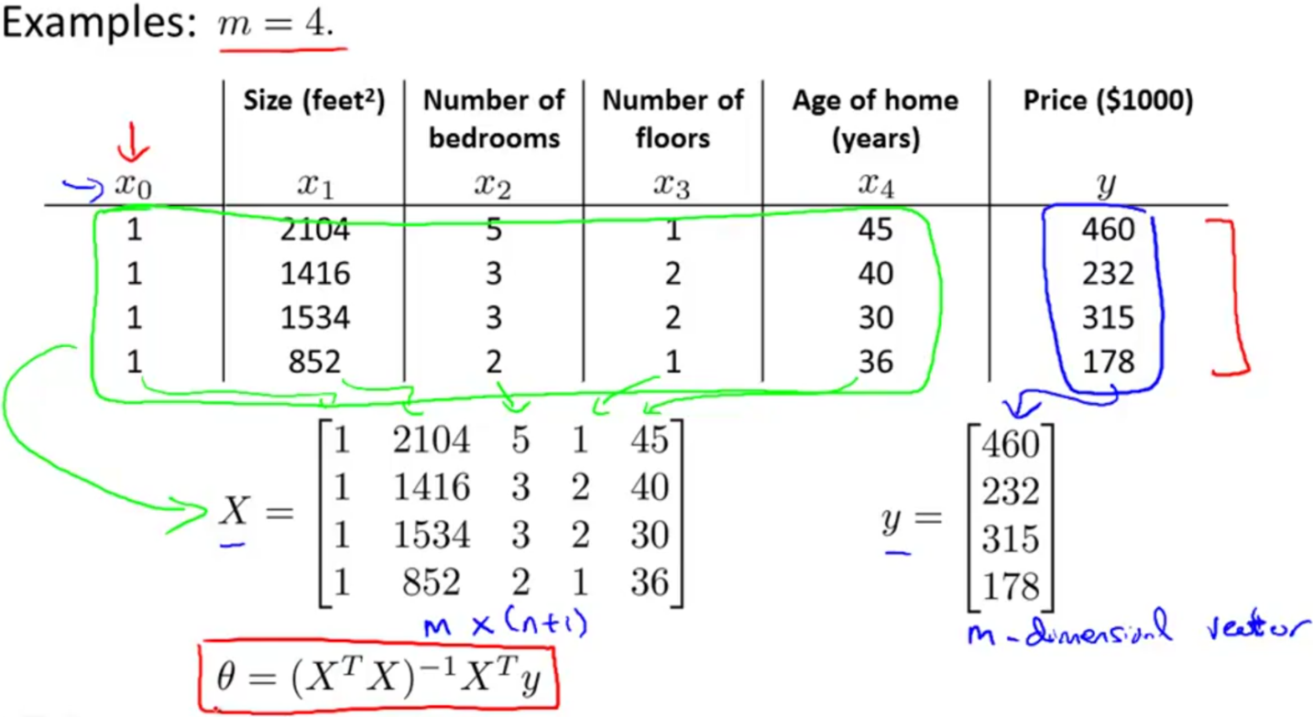

If $X^{T}X$  is **noninvertible,** the common causes might be having:

* Redundant features, where two features are very closely related (i.e. they are linearly dependent)
* Too many features (e.g. m ≤ n). In this case, delete some features or use "regularization".

Solutions to the above problems include deleting a feature that is linearly dependent with another or deleting one or more features when there are too many features.

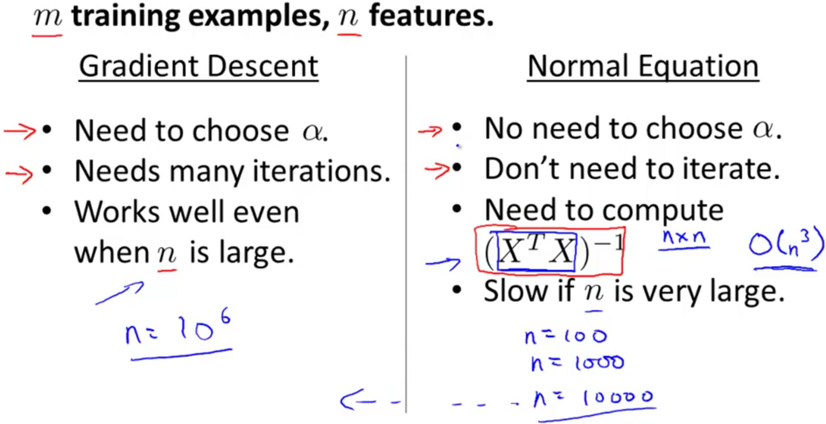

**WEEK 3**

Classification

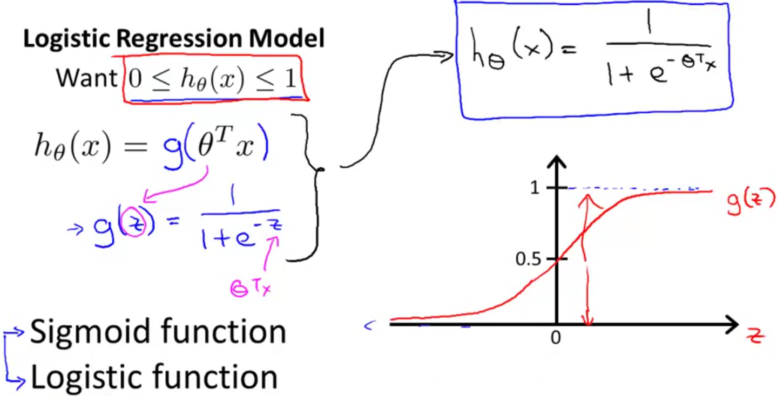

The function g(z), shown here, maps any real number to the (0, 1) interval, making it useful for transforming an arbitrary-valued function into a function better suited for classification.

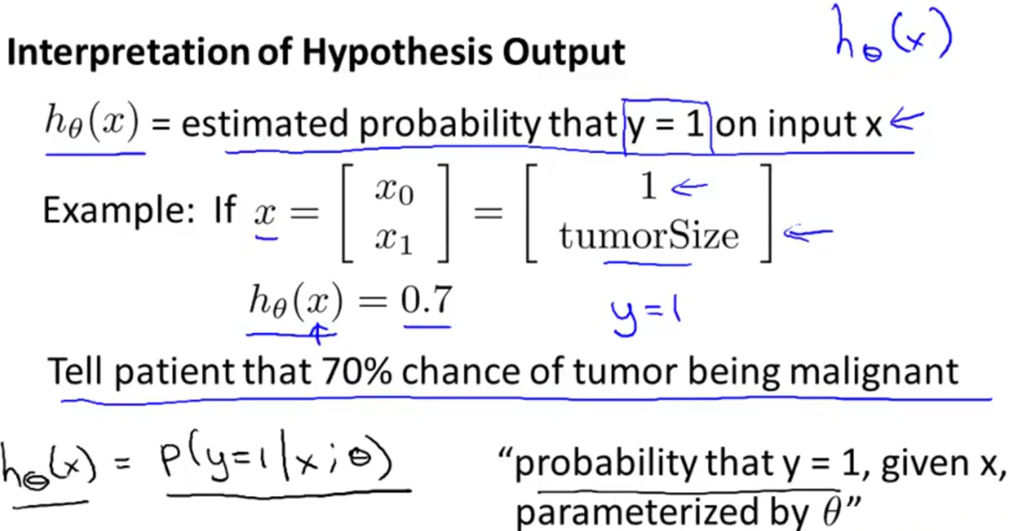

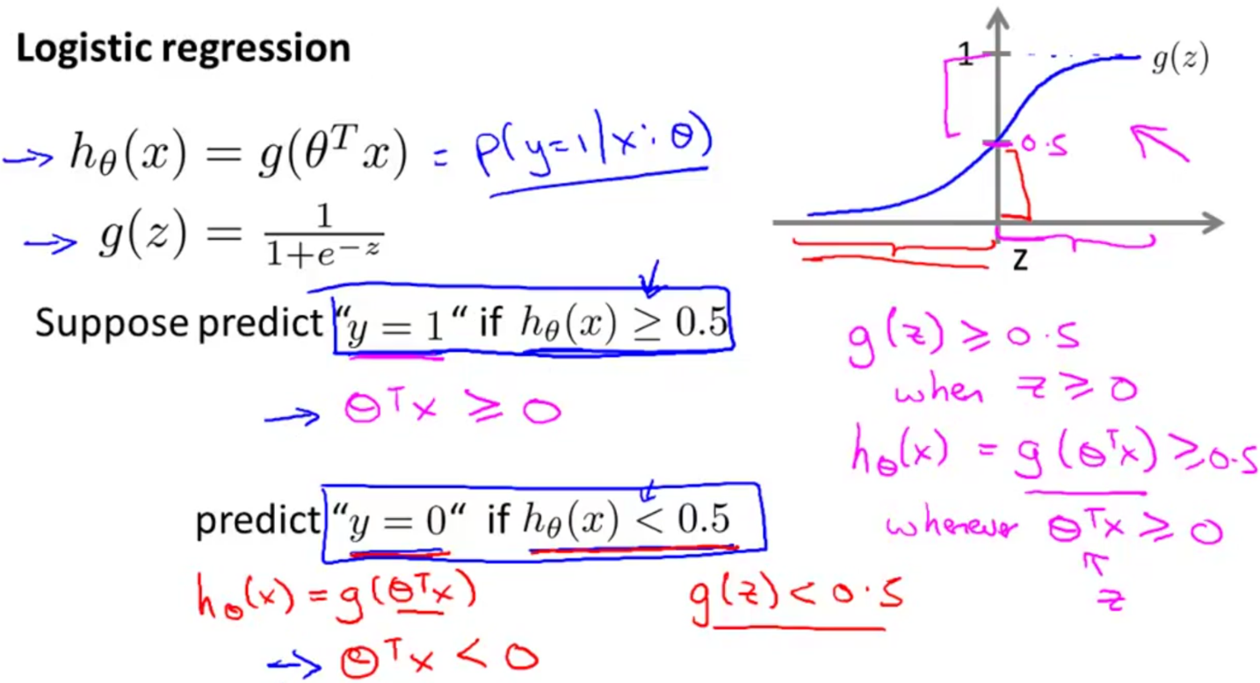

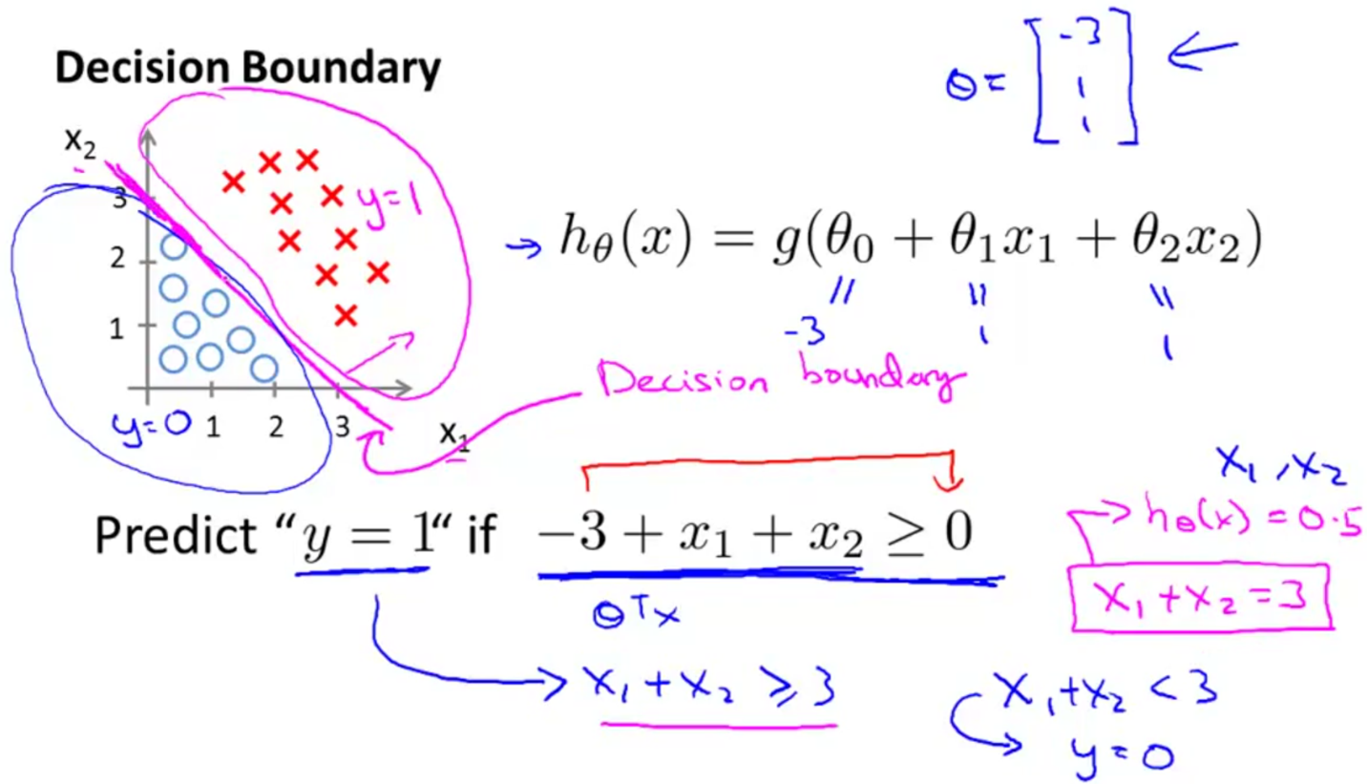

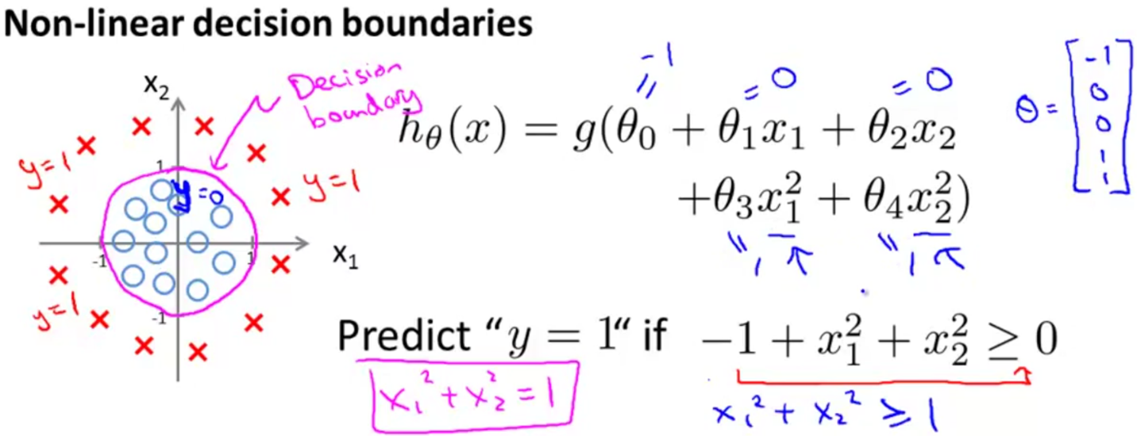

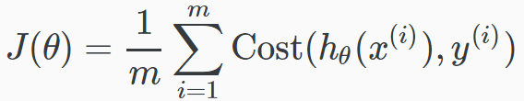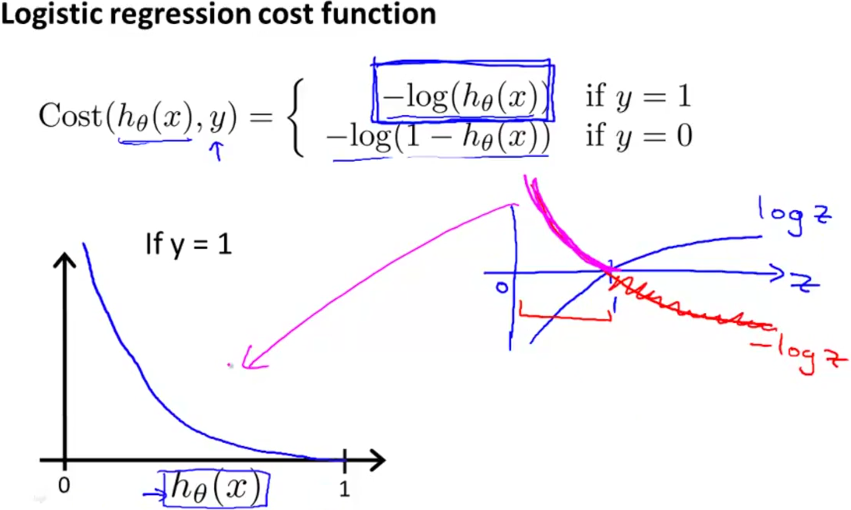

* **Note that writing the cost function in this way guarantees that J(θ) is convex for logistic regression.**

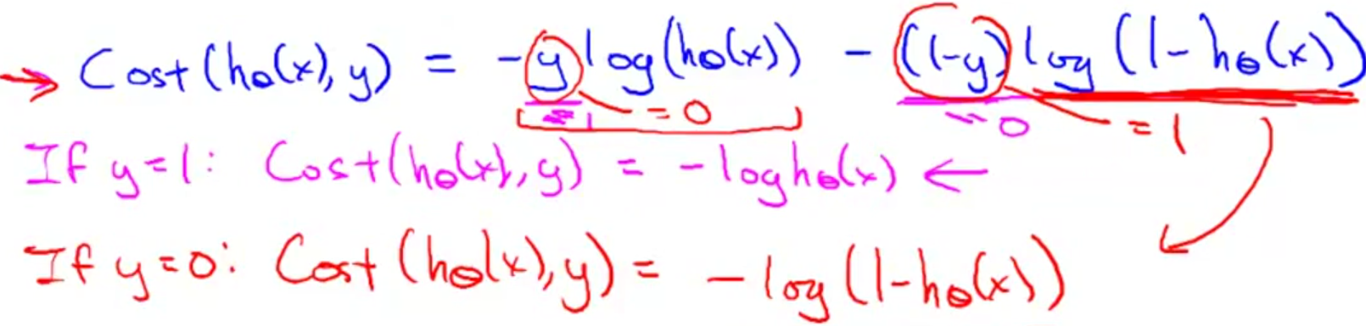Simplified form:

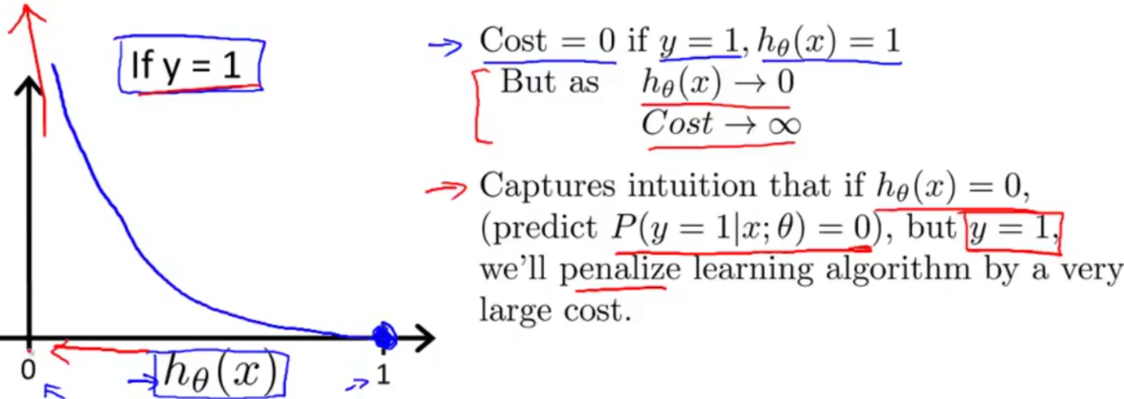

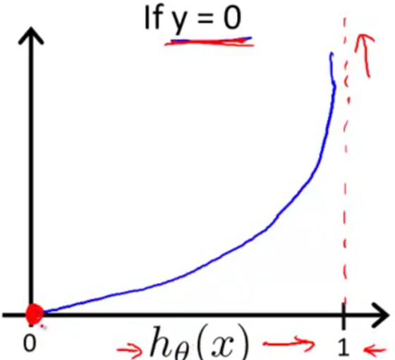If our correct answer 'y' is 0, then the cost function will be 0 if our hypothesis function also outputs 0. If our hypothesis approaches 1, then the cost function will approach infinity.

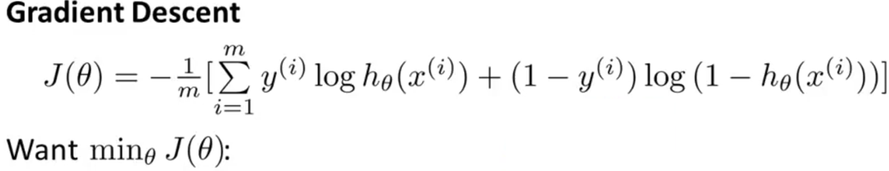

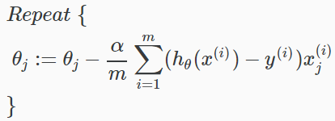



Multiclass Classification

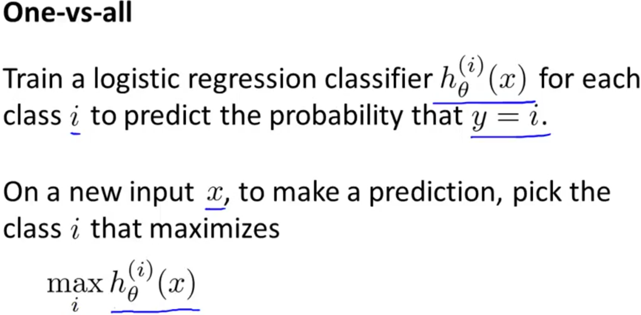

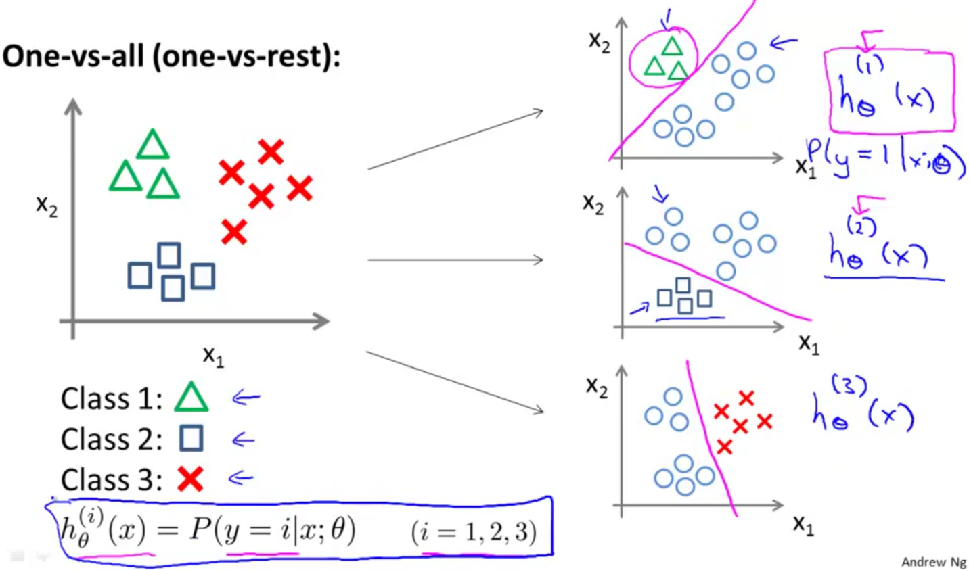

The Problem of Overfitting

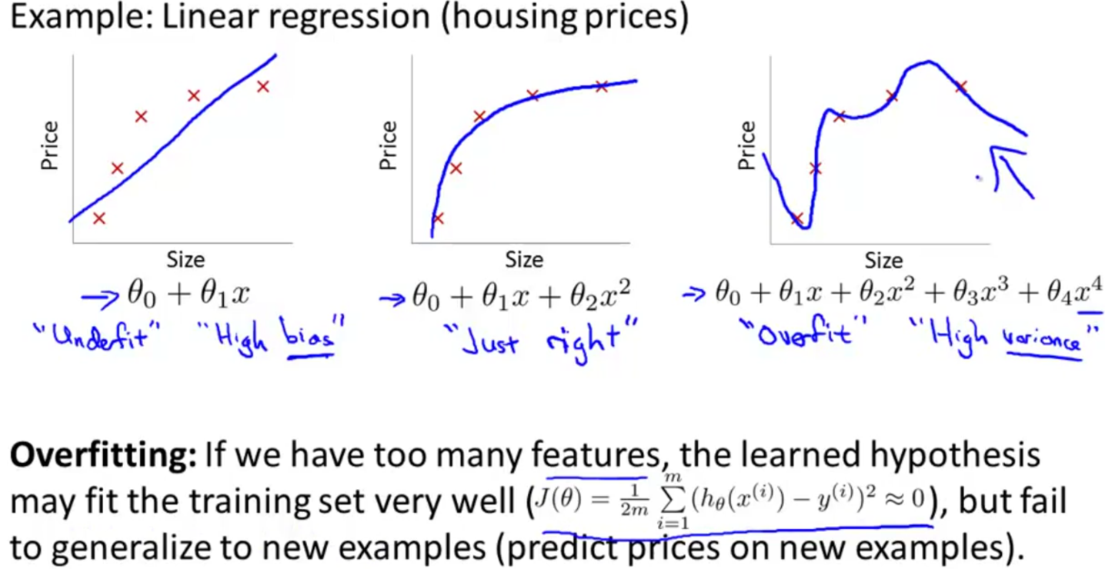

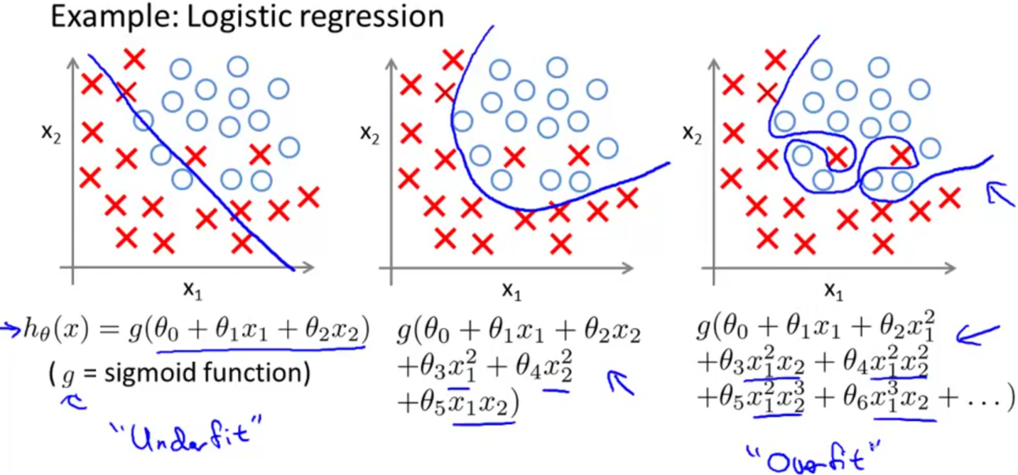

How to Address Overfitting

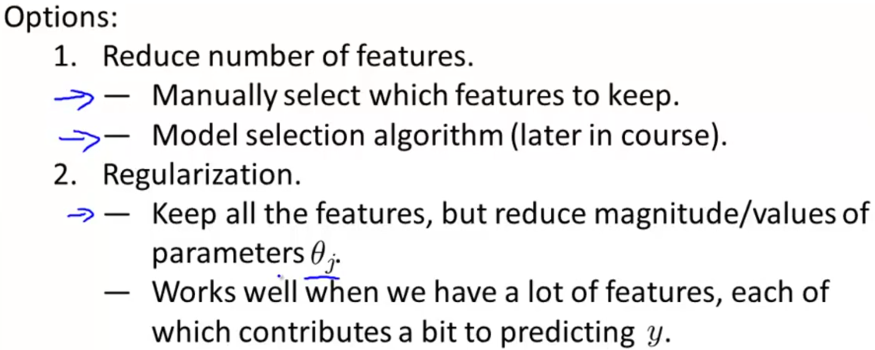

Regularization

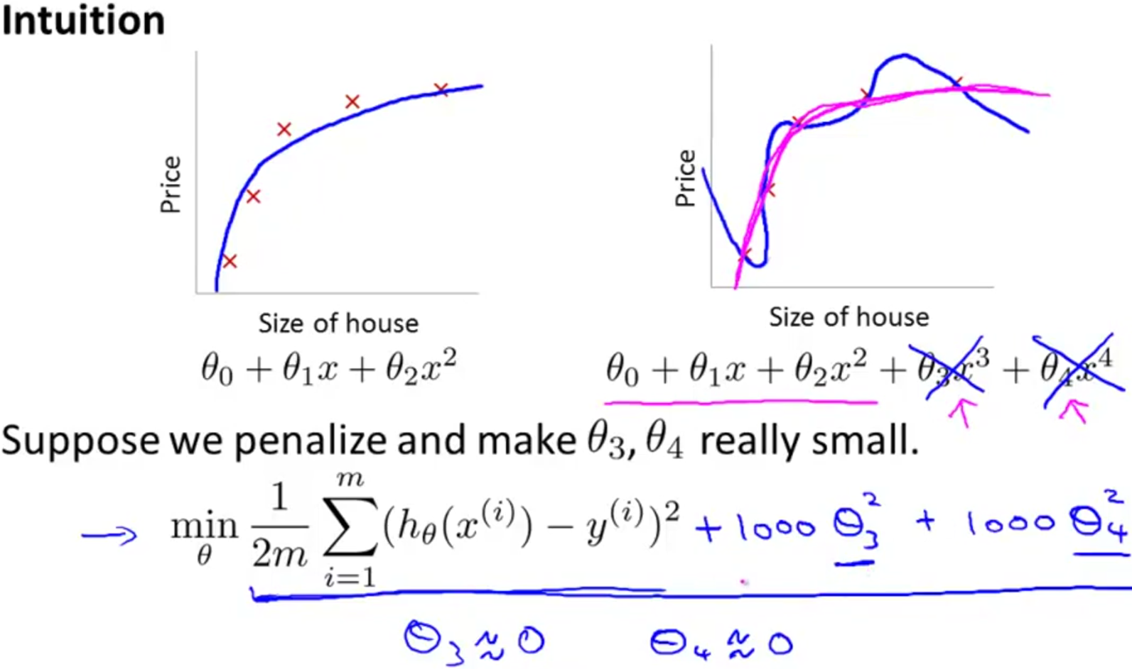

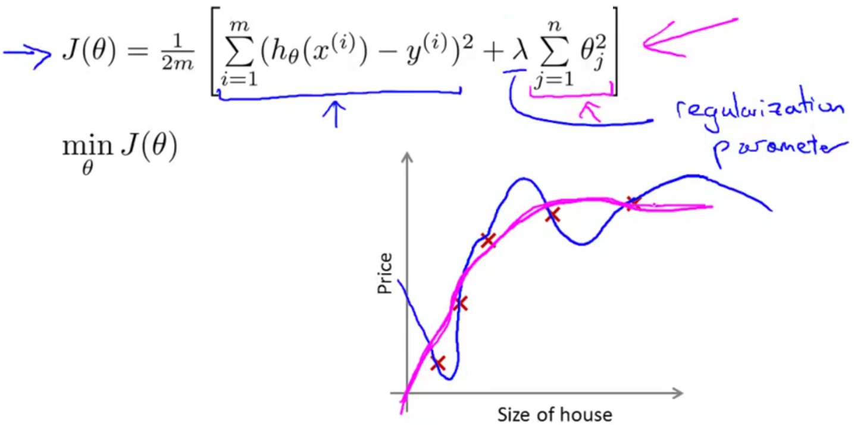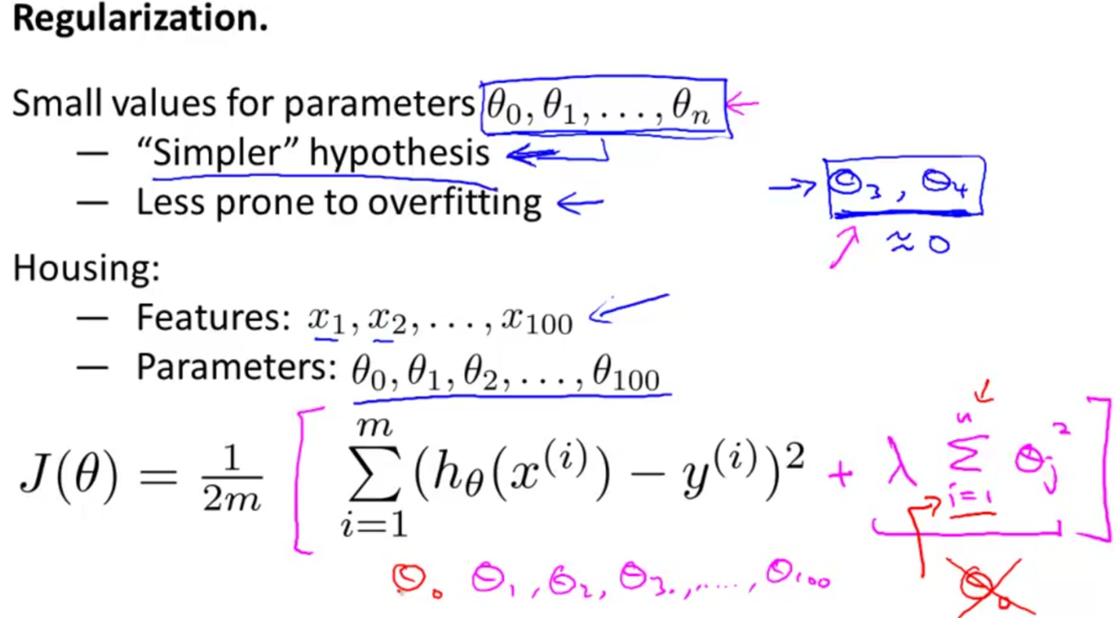

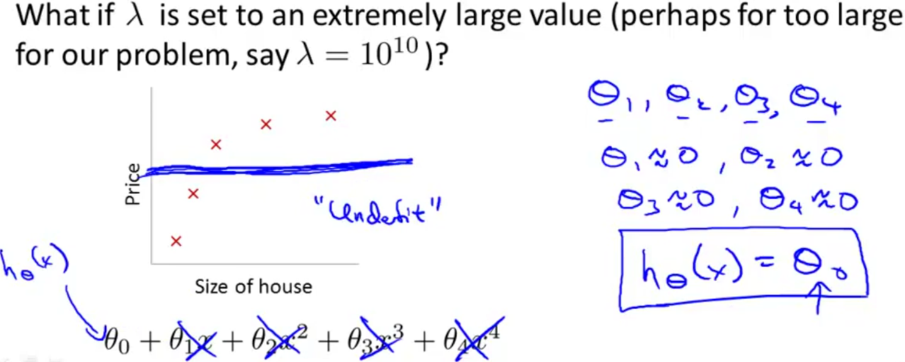

Regularized Linear Regression

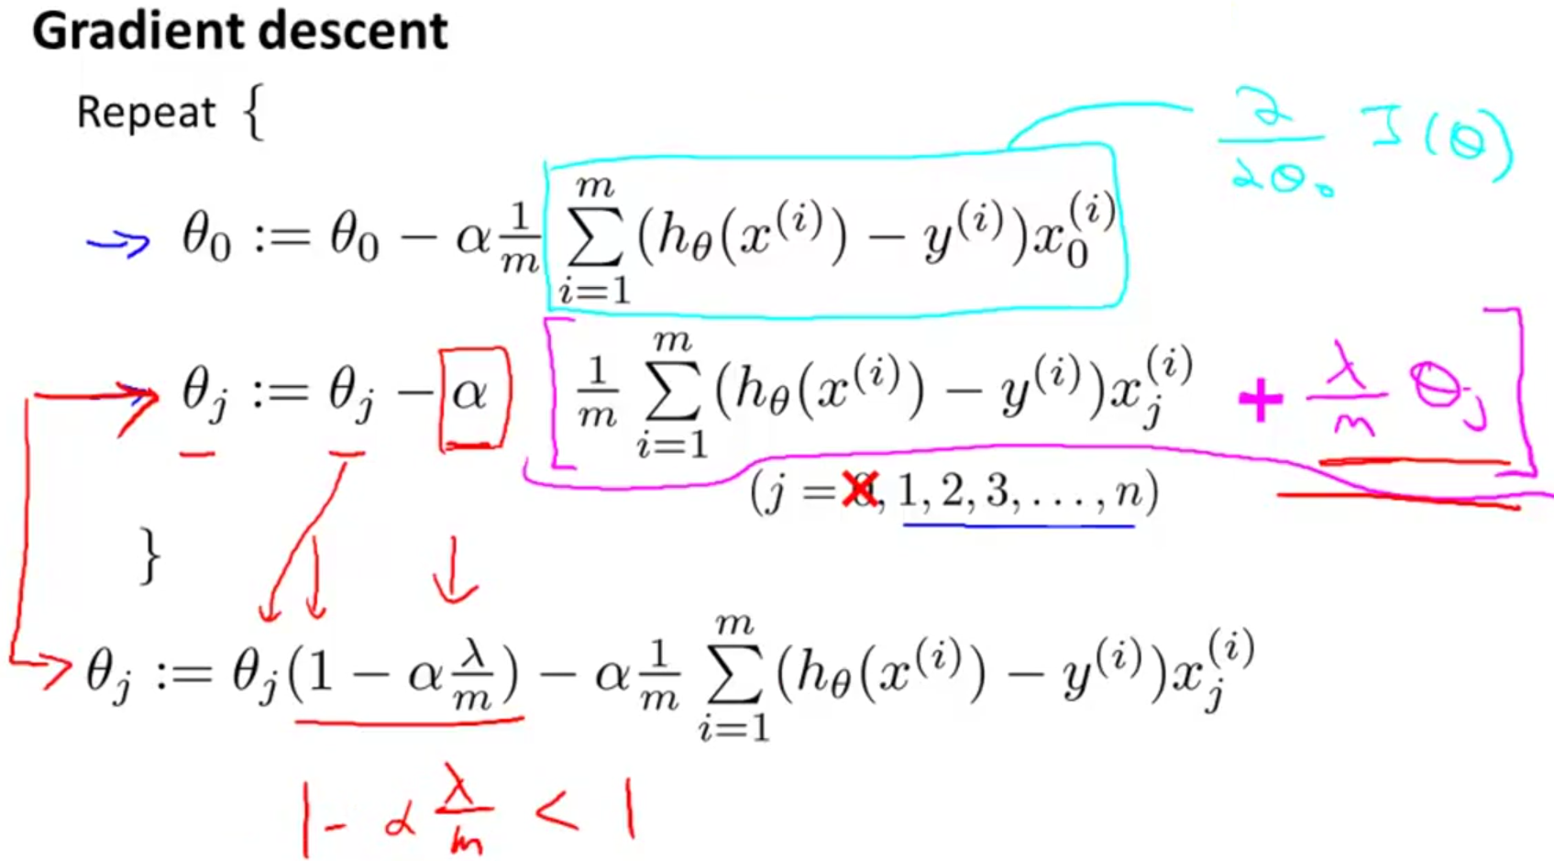

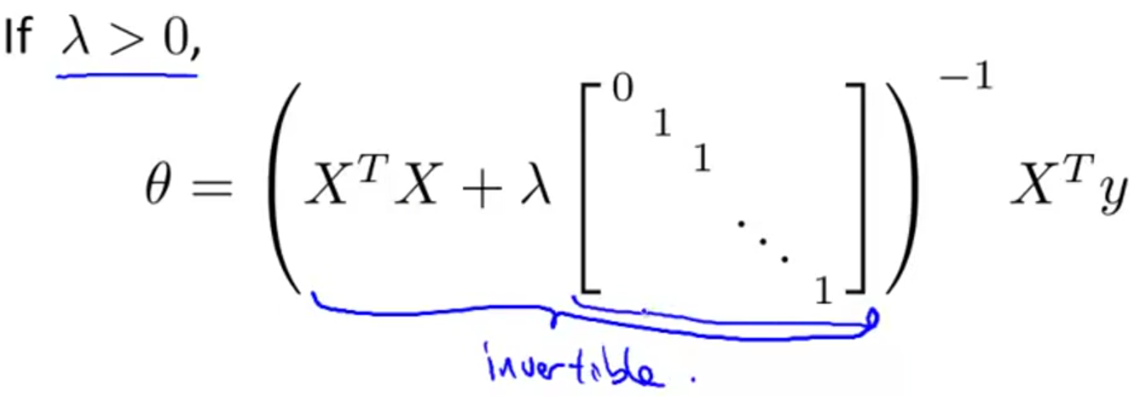

Regularized Logistic Regression

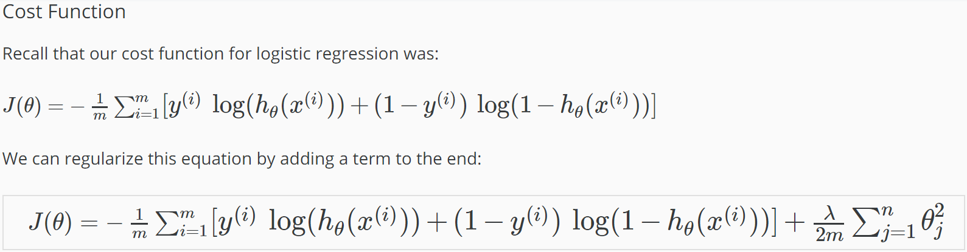

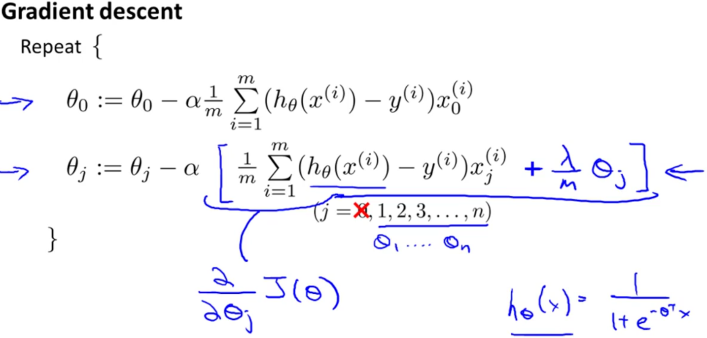

**WEEK 4**

Neural Networks

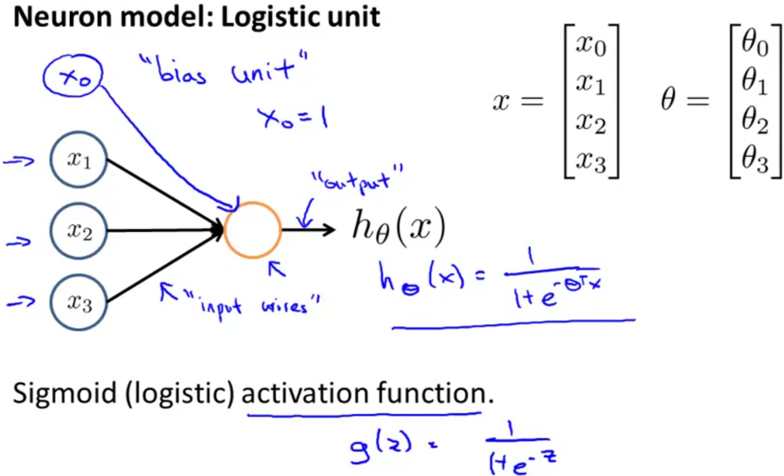

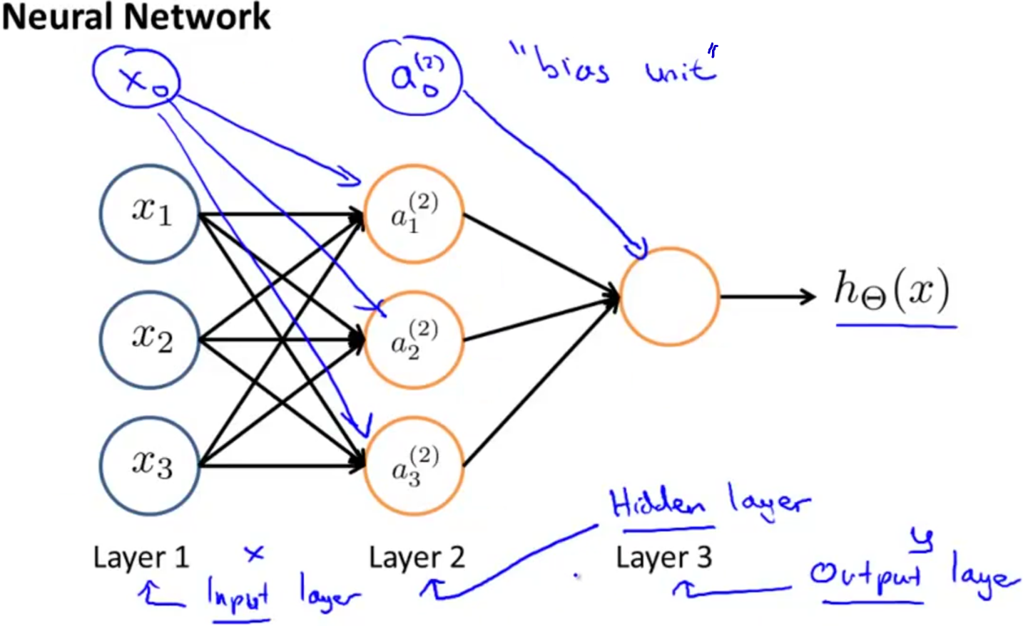

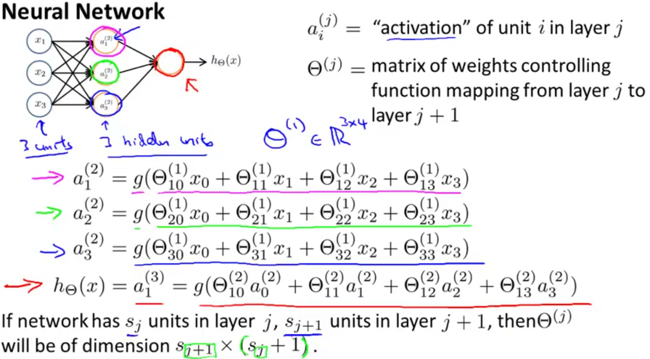

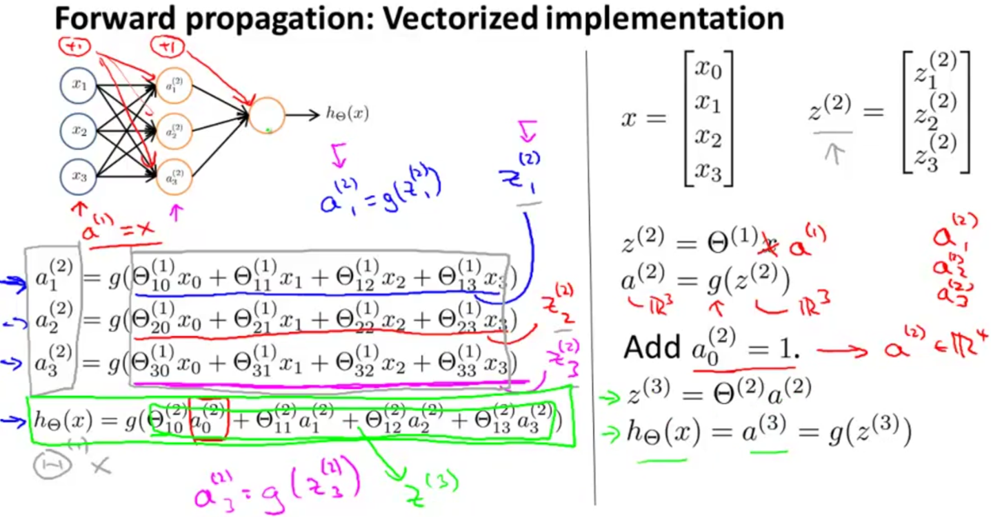

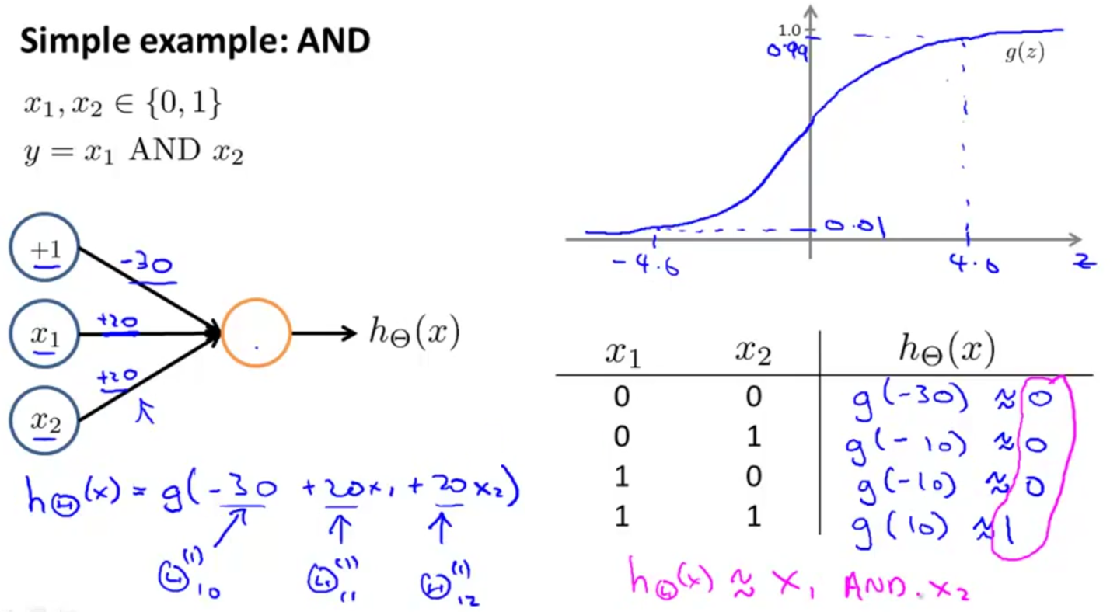

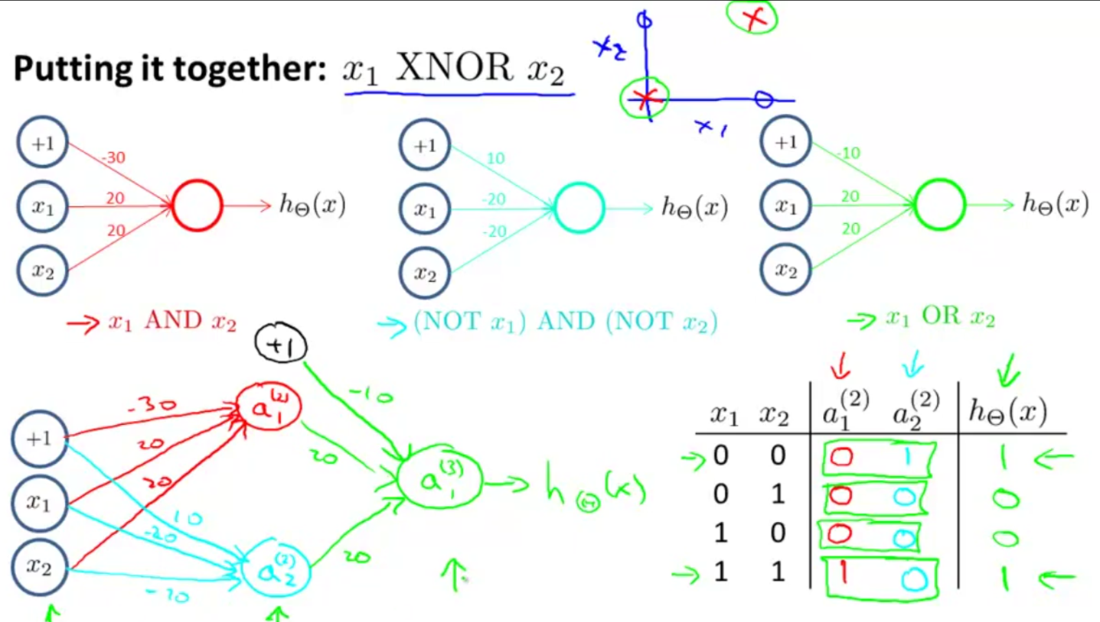

# **Multiclass Classification**

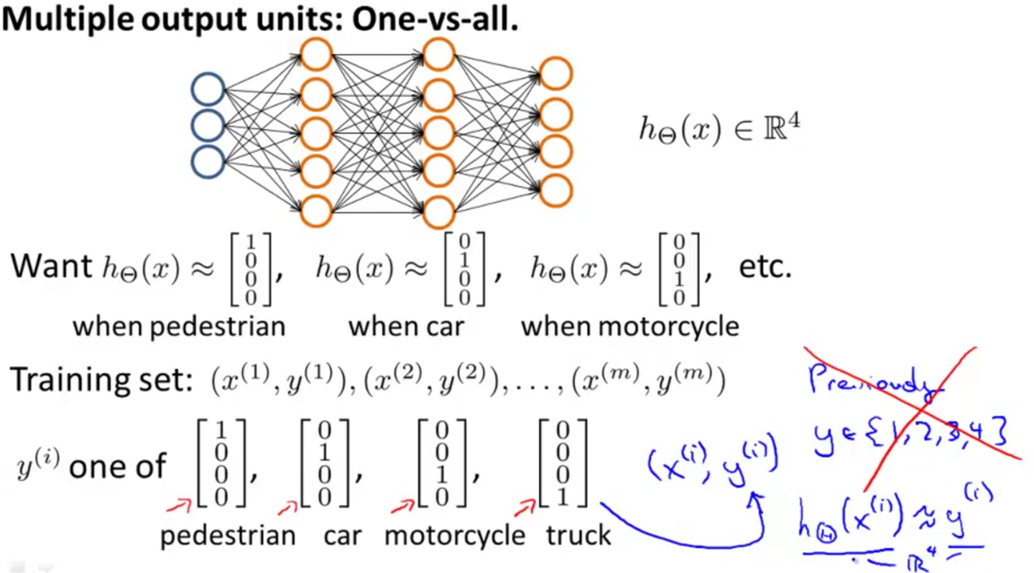

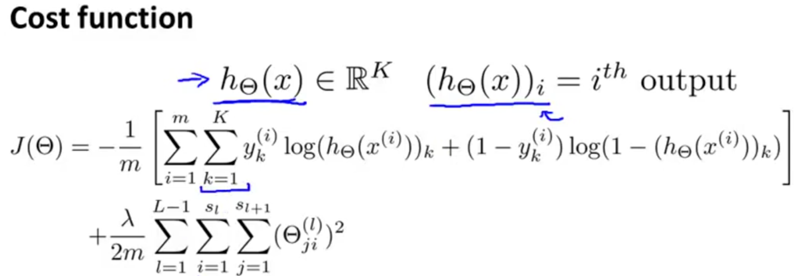

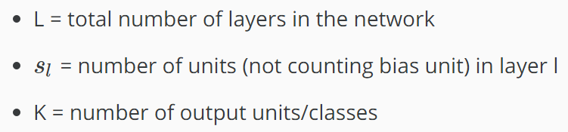

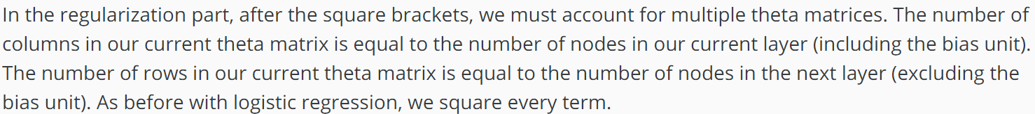

**WEEK 5**

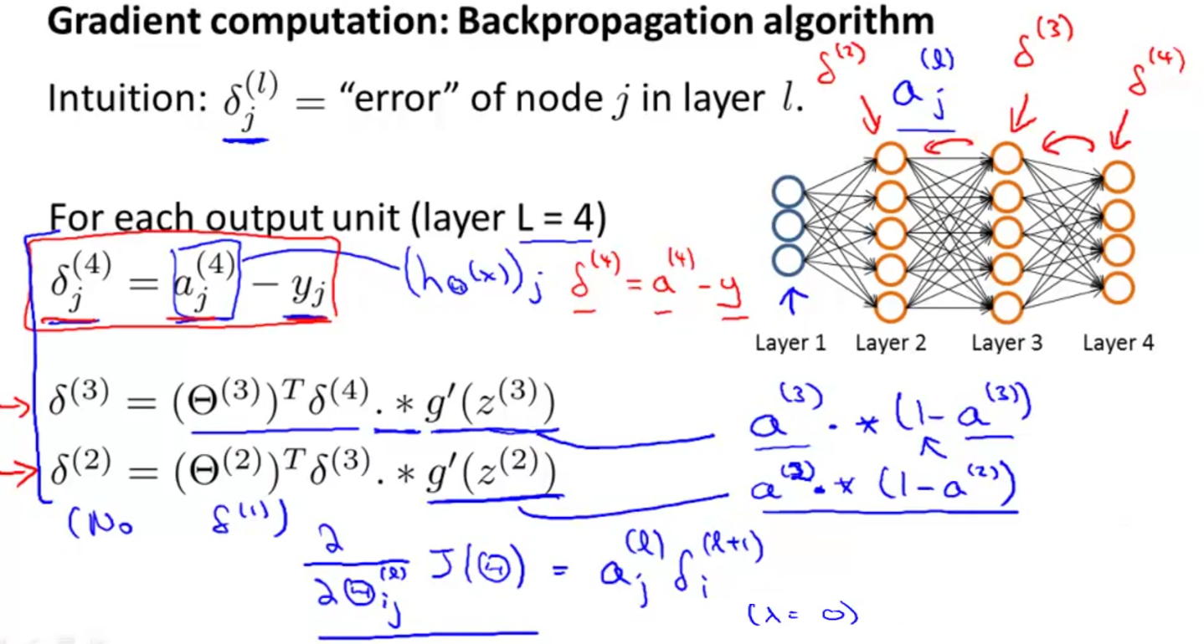

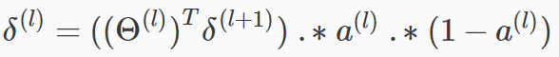

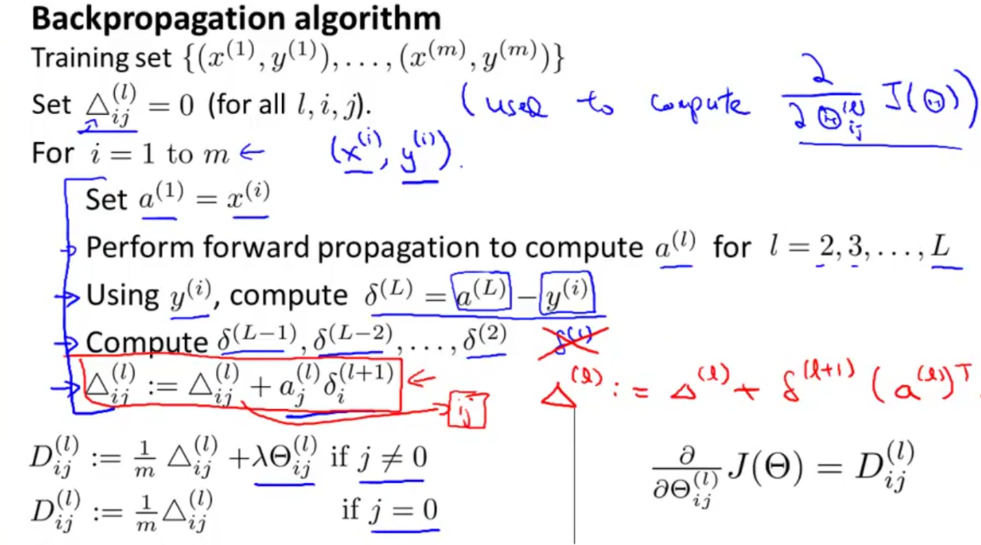

# **MATLAB Implementation Notes**

In order to use optimizing functions such as fminunc(), we will want to "unroll" all the elements and put them into one long vector:

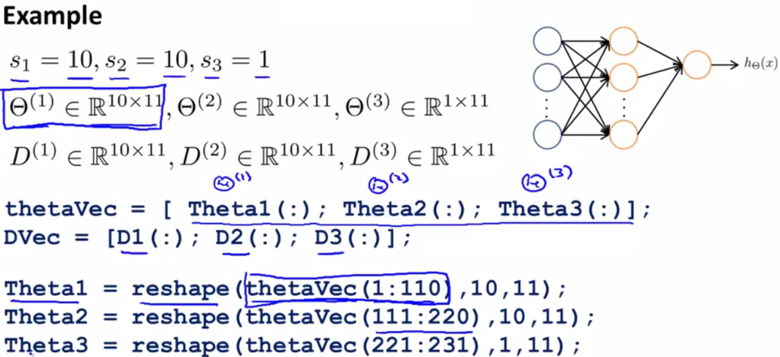

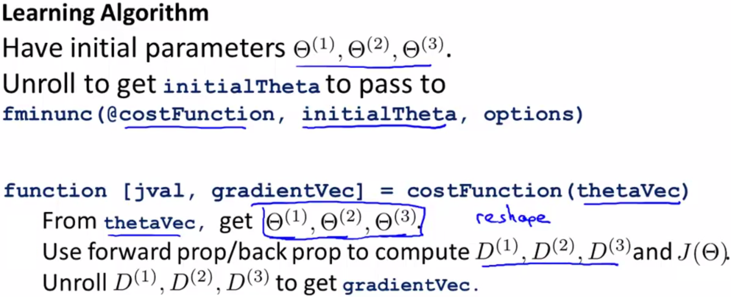

# **Gradient Checking**

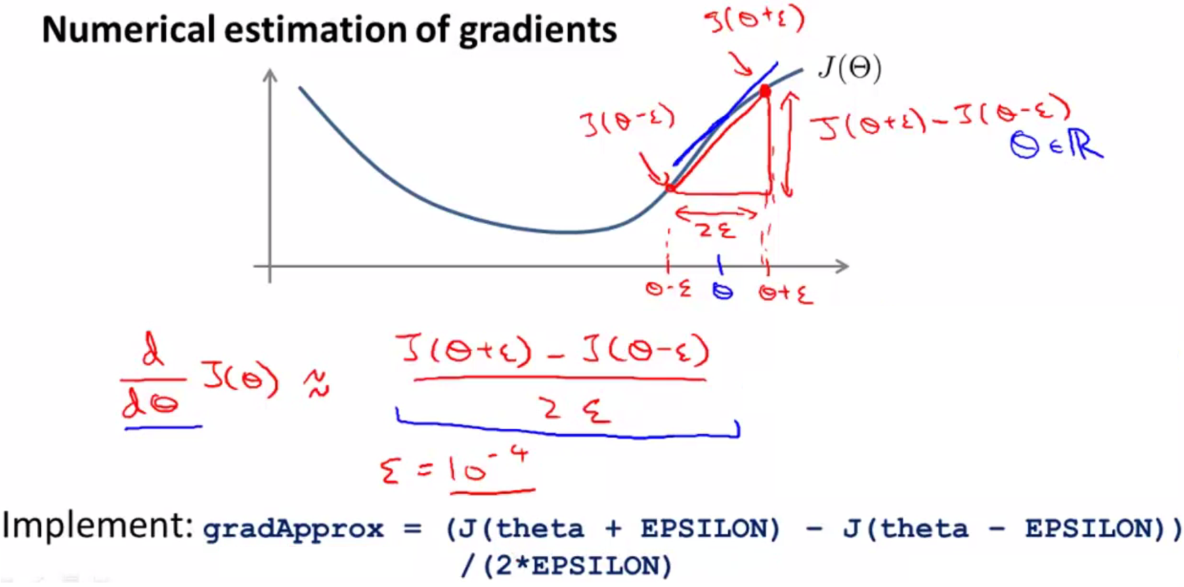

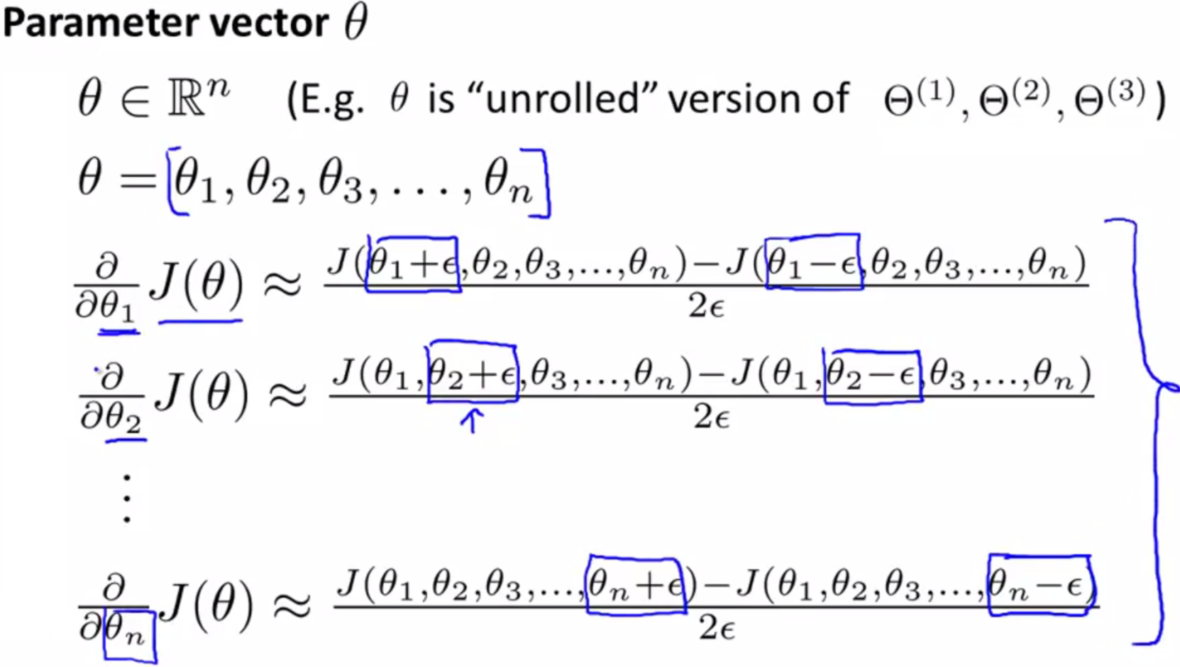

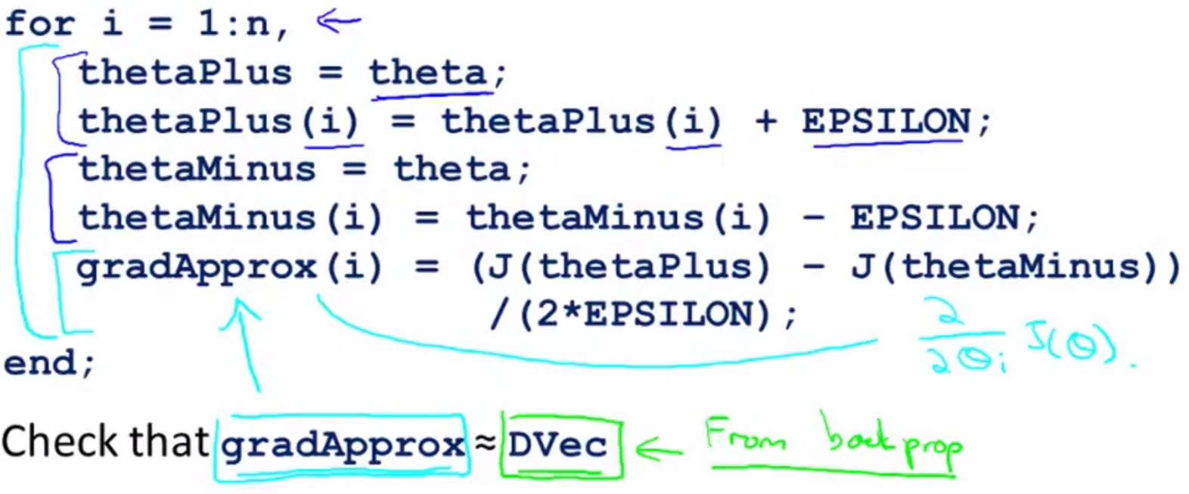

# **Random Initialization**

Initializing all theta weights to zero does not work with neural networks. When we backpropagate, all nodes will update to the same value repeatedly. Instead we can randomly initialize our weights for our Θ matrices using the following method:

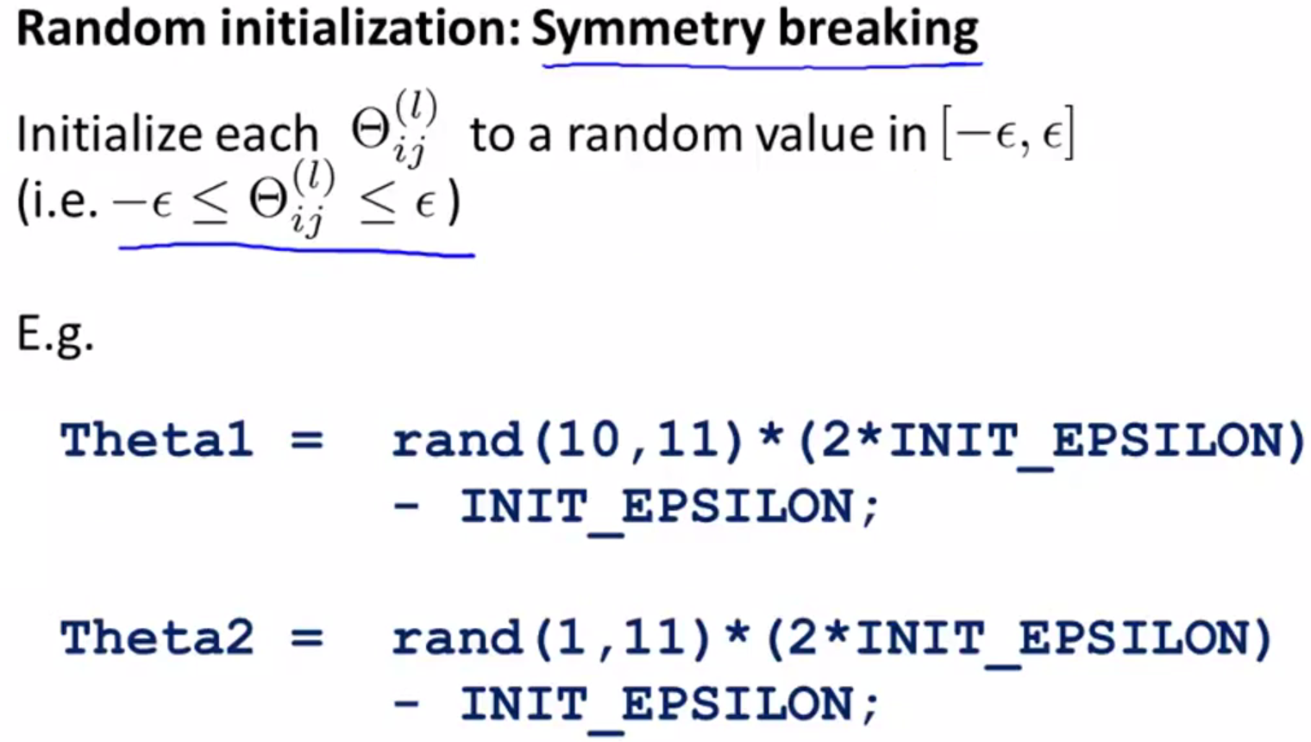

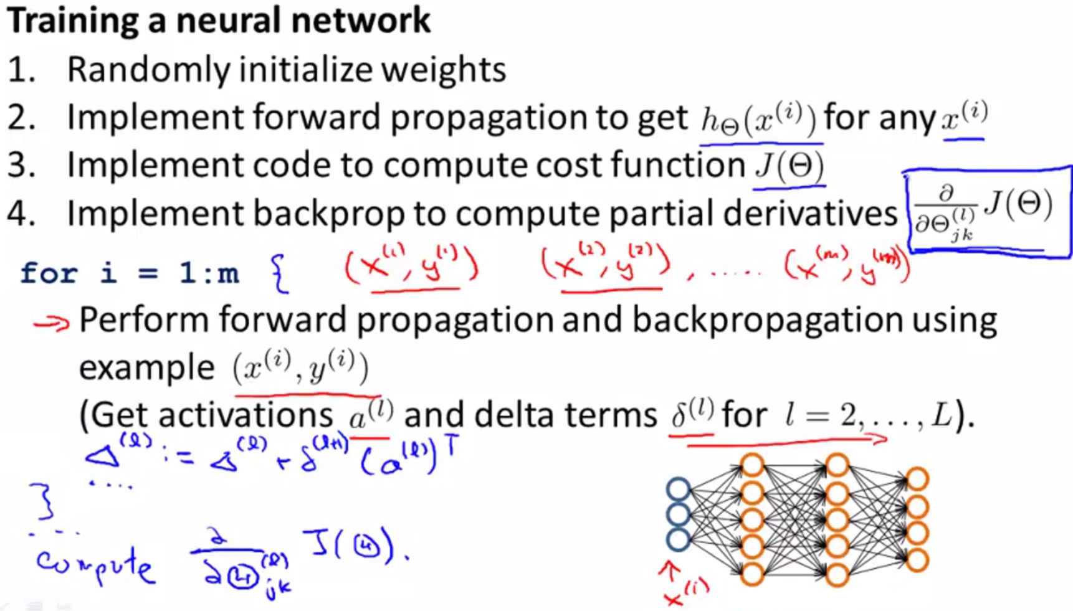

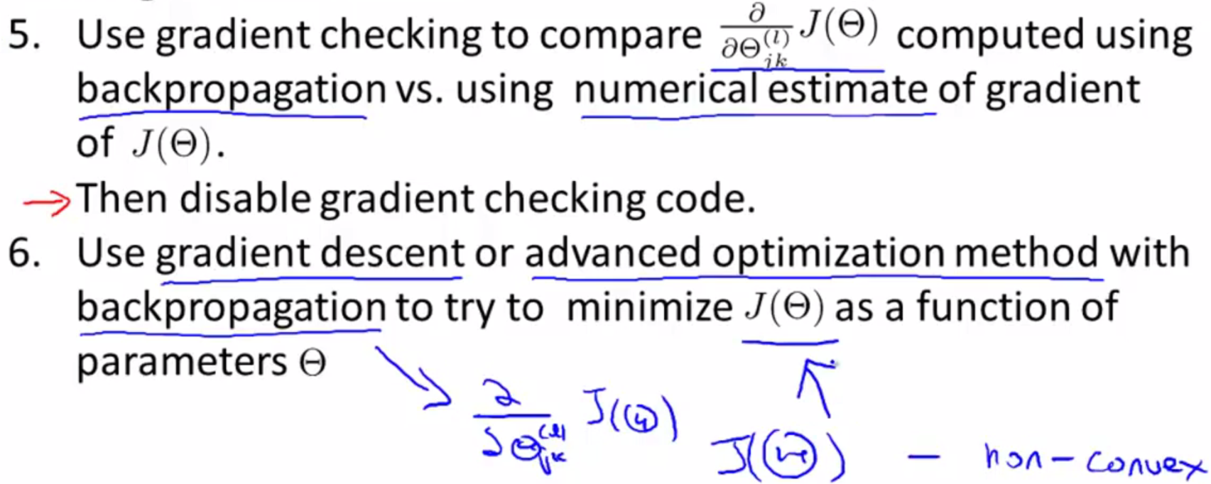

**WEEK 6**

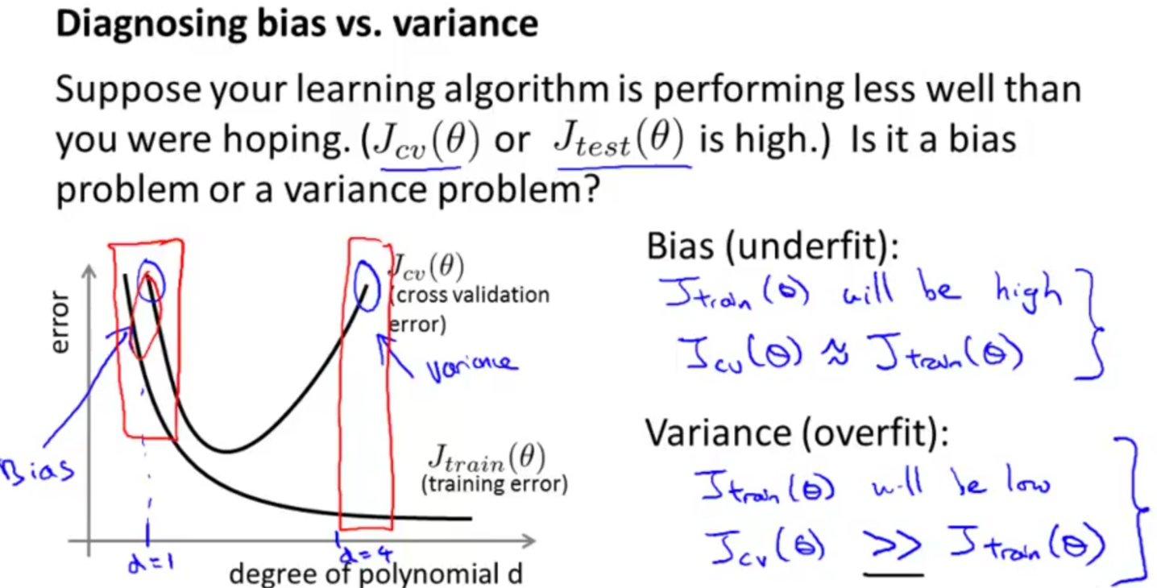

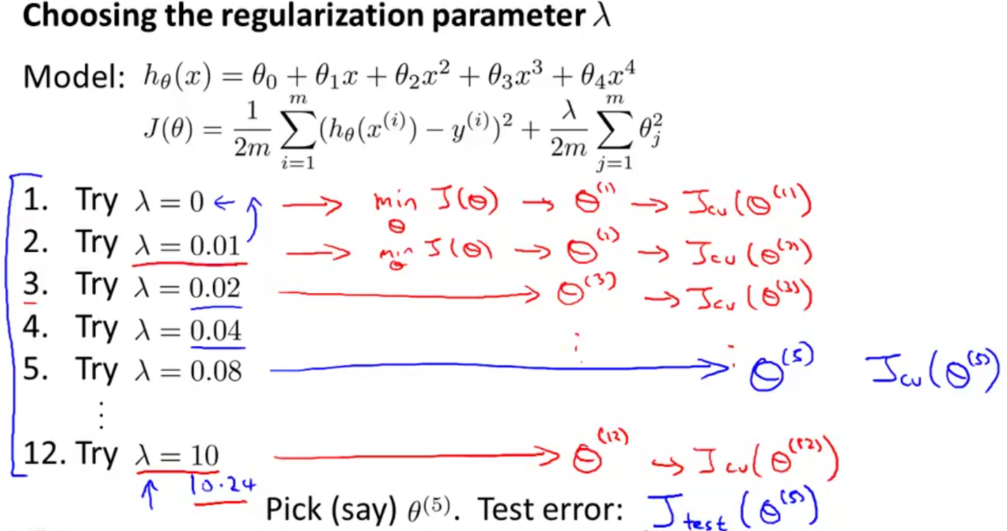

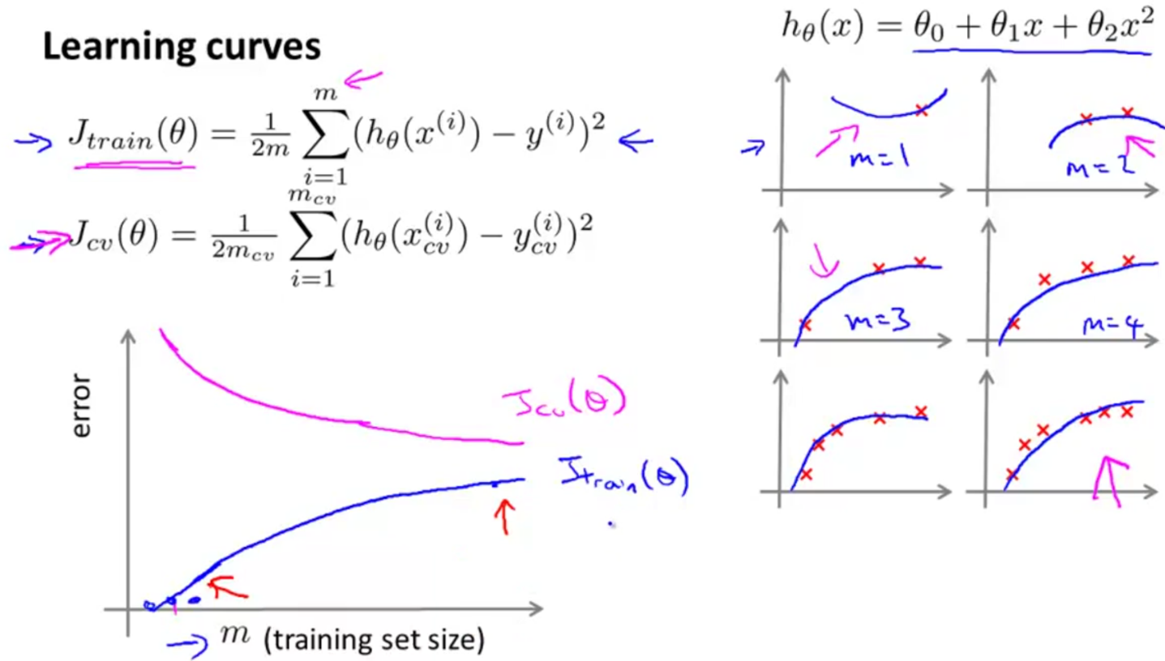

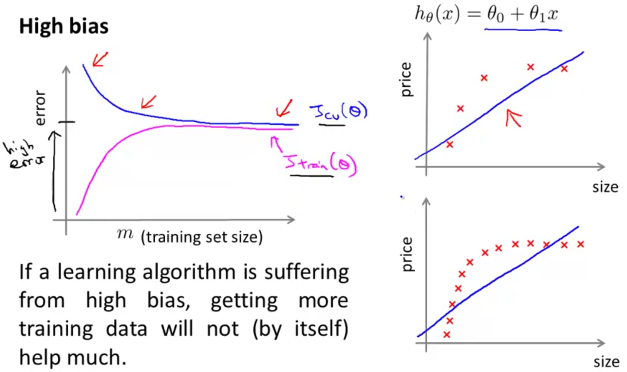

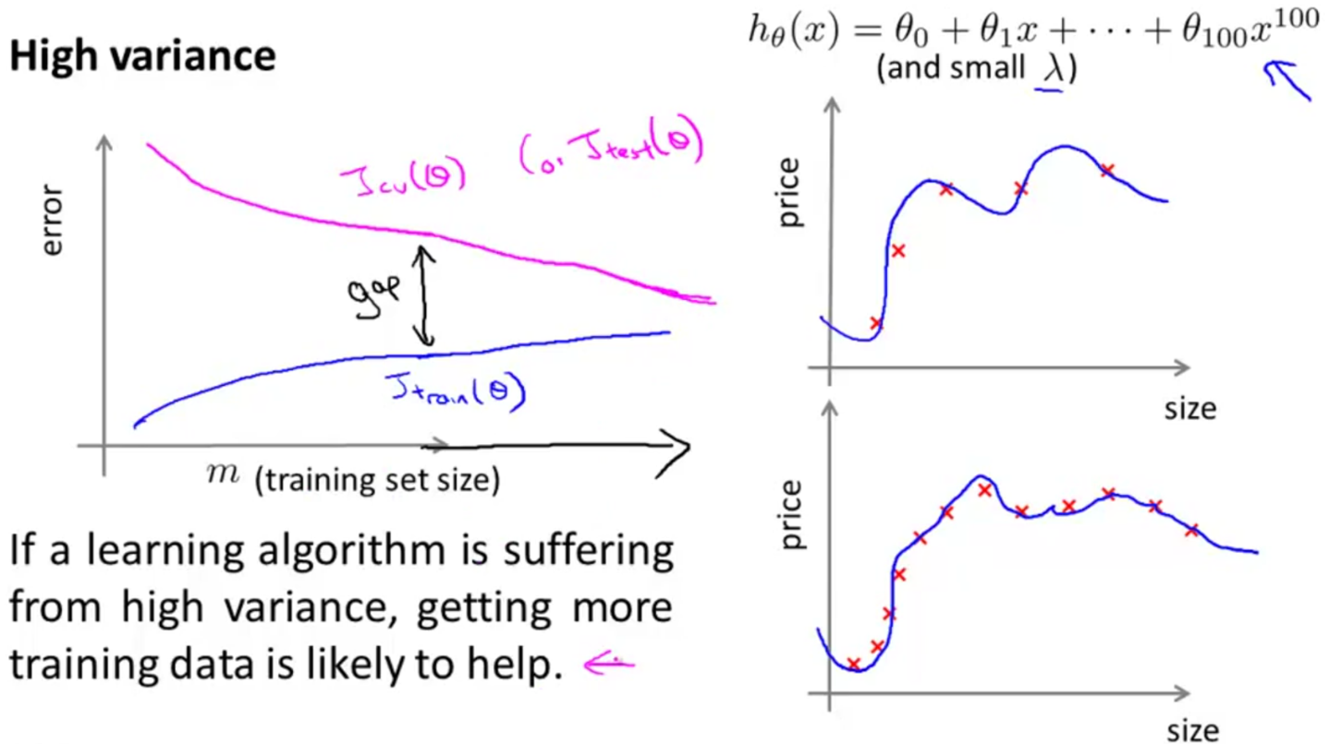

# **Prioritizing What to Work On**

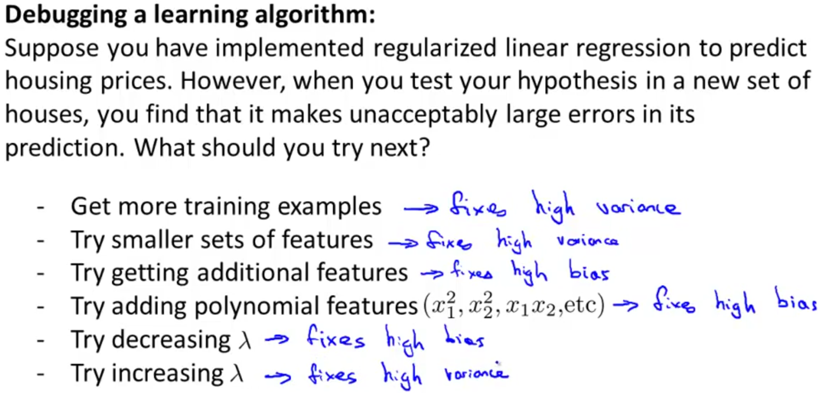

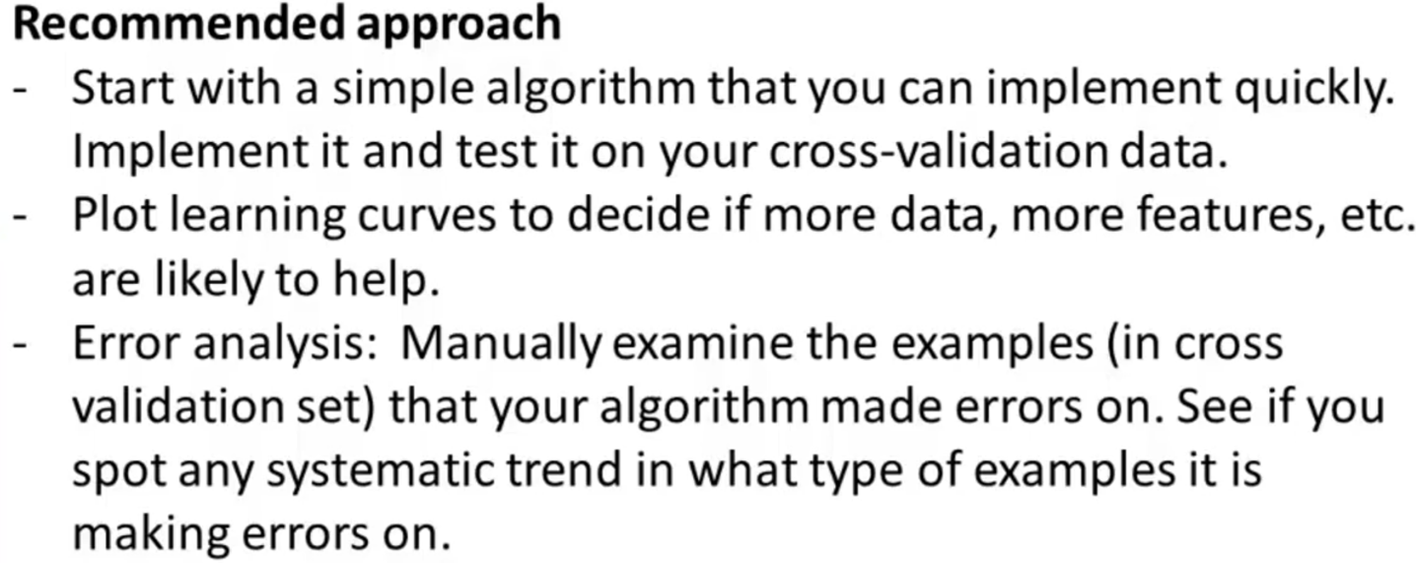

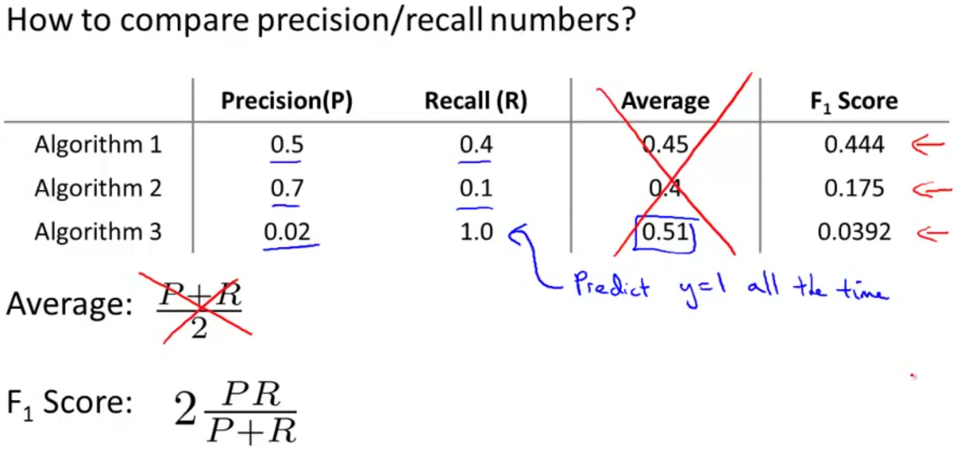

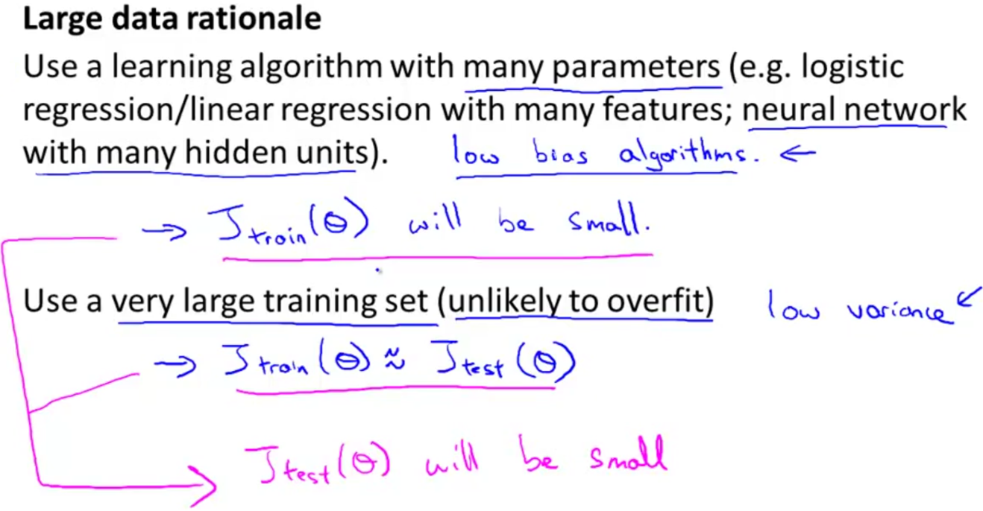

**WEEK 7**

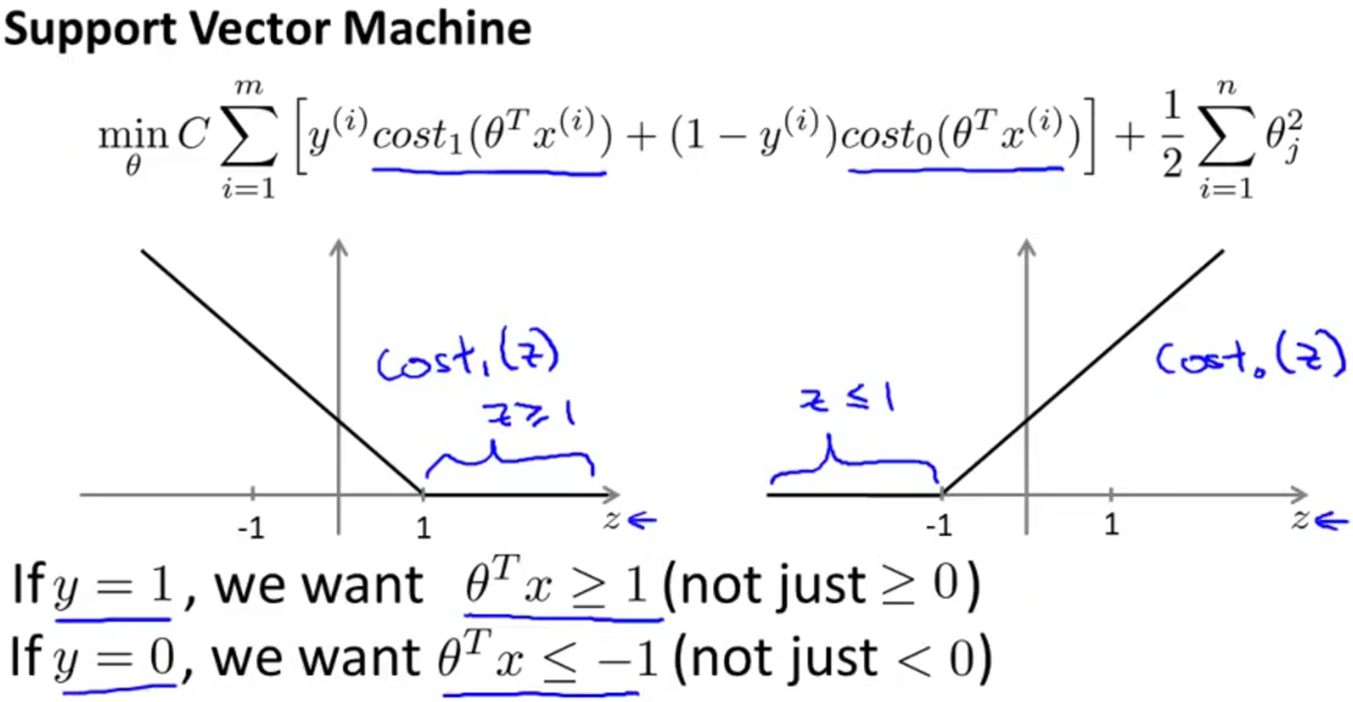

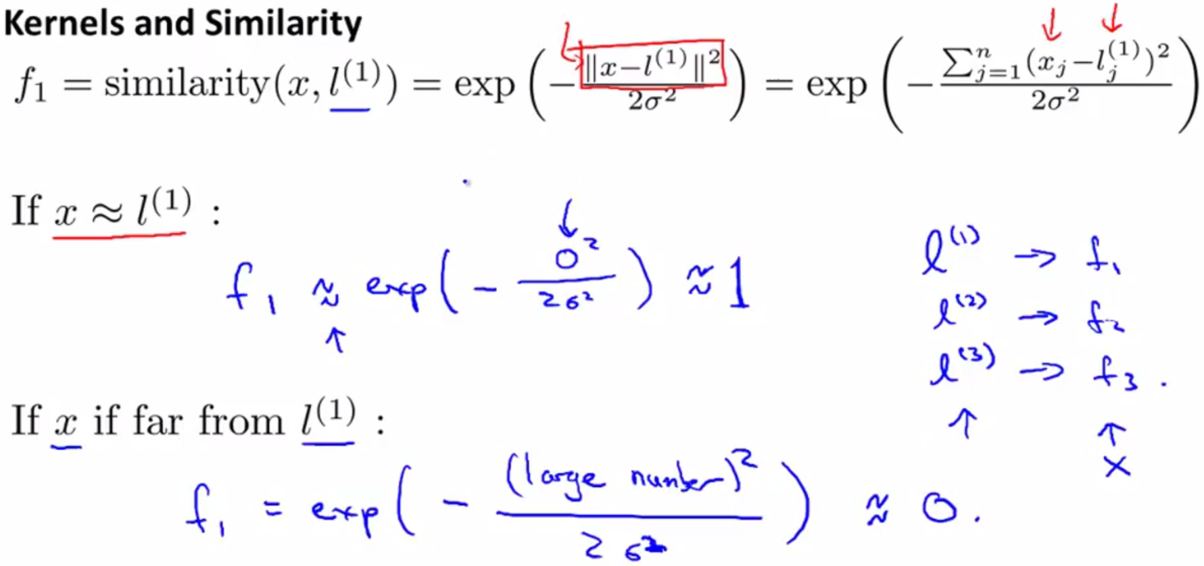

# **Gaussian Kernel**

